ETIQUETAS PARA LIBROS Y CUADERNOS ANGRY BIRDS



NOMBRE: ____________________________________________

CURSO: _____________________________________________

COLEGIO: ____________________________________________

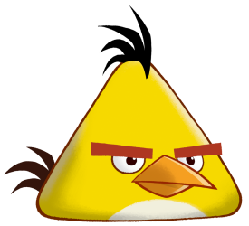

NOMBRE: ____________________________________________

CURSO: _____________________________________________

COLEGIO: ____________________________________________



NOMBRE: ____________________________________________

CURSO: _____________________________________________

COLEGIO: ____________________________________________

NOMBRE: ____________________________________________

CURSO: _____________________________________________

COLEGIO: ____________________________________________

NOMBRE: ____________________________________________

CURSO: _____________________________________________

COLEGIO: ____________________________________________