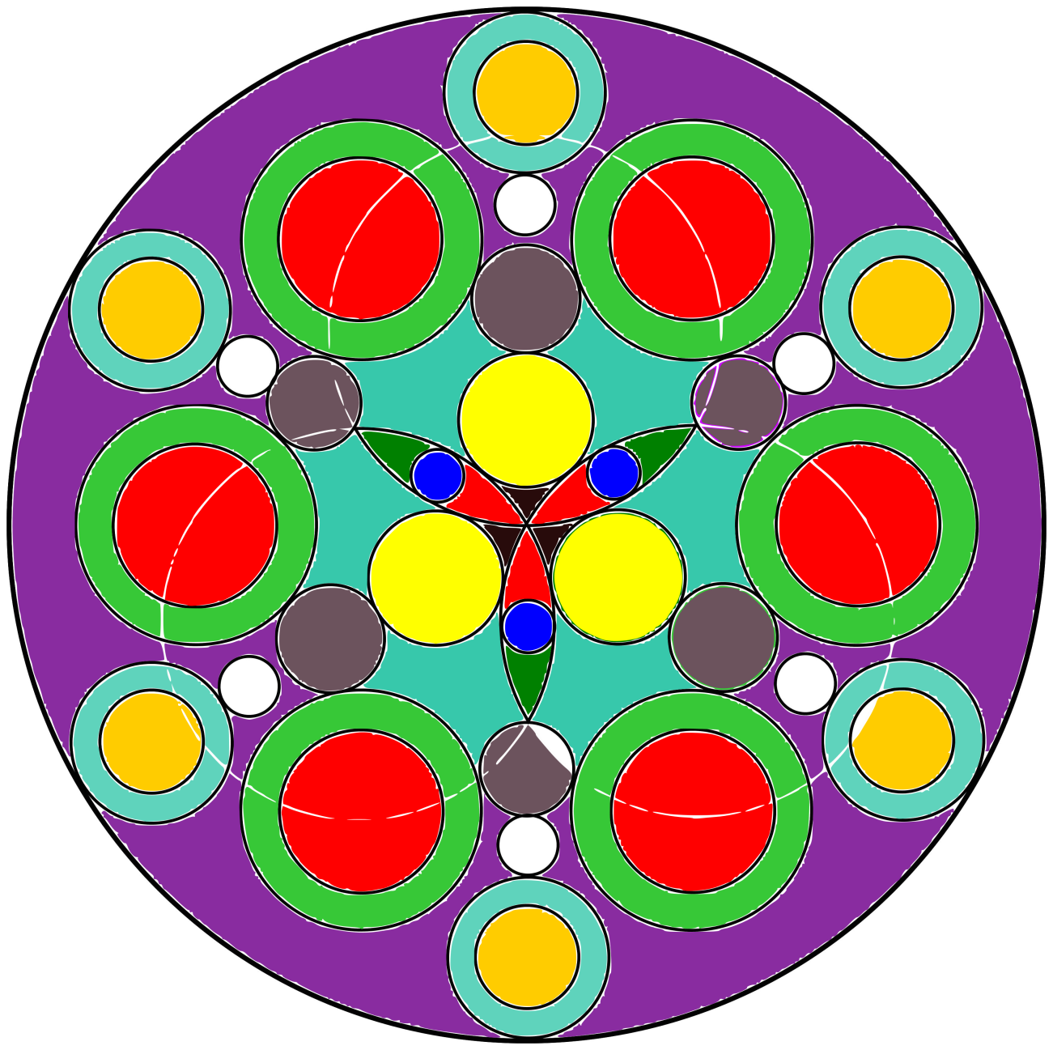**­­Mandalas**

**[android-mandalas](https://play.google.com/store/apps/details?id=com.crud.mandala.app)**

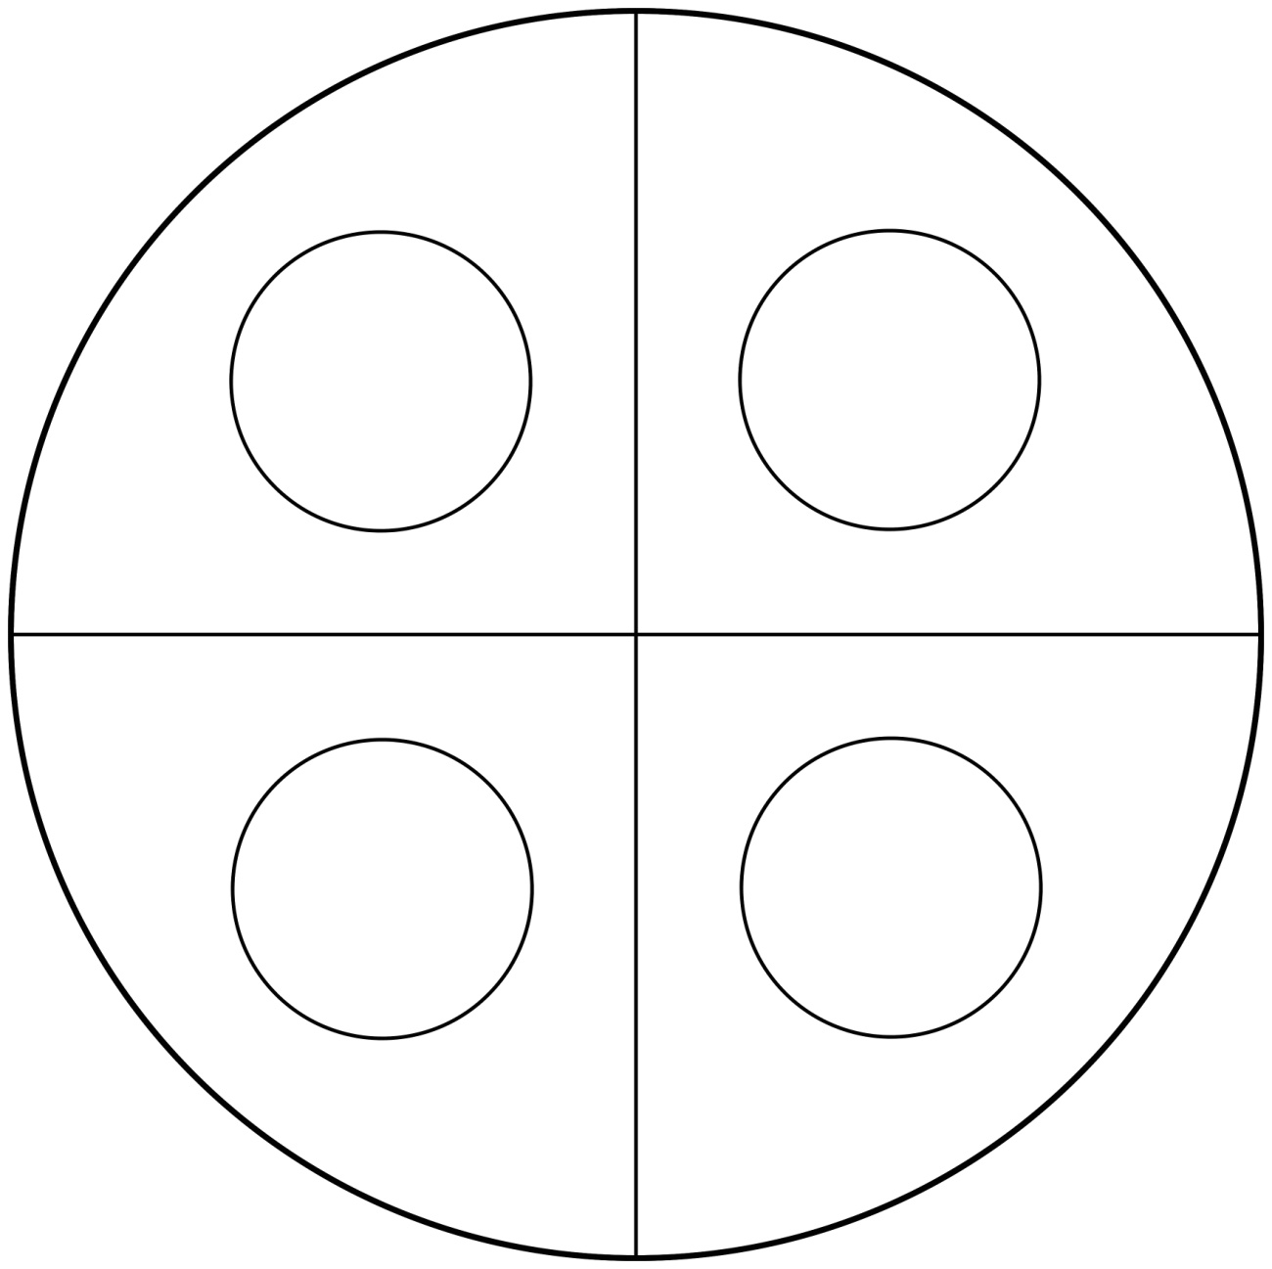

**[android-mandalas](https://play.google.com/store/apps/details?id=com.crud.mandala.app)**

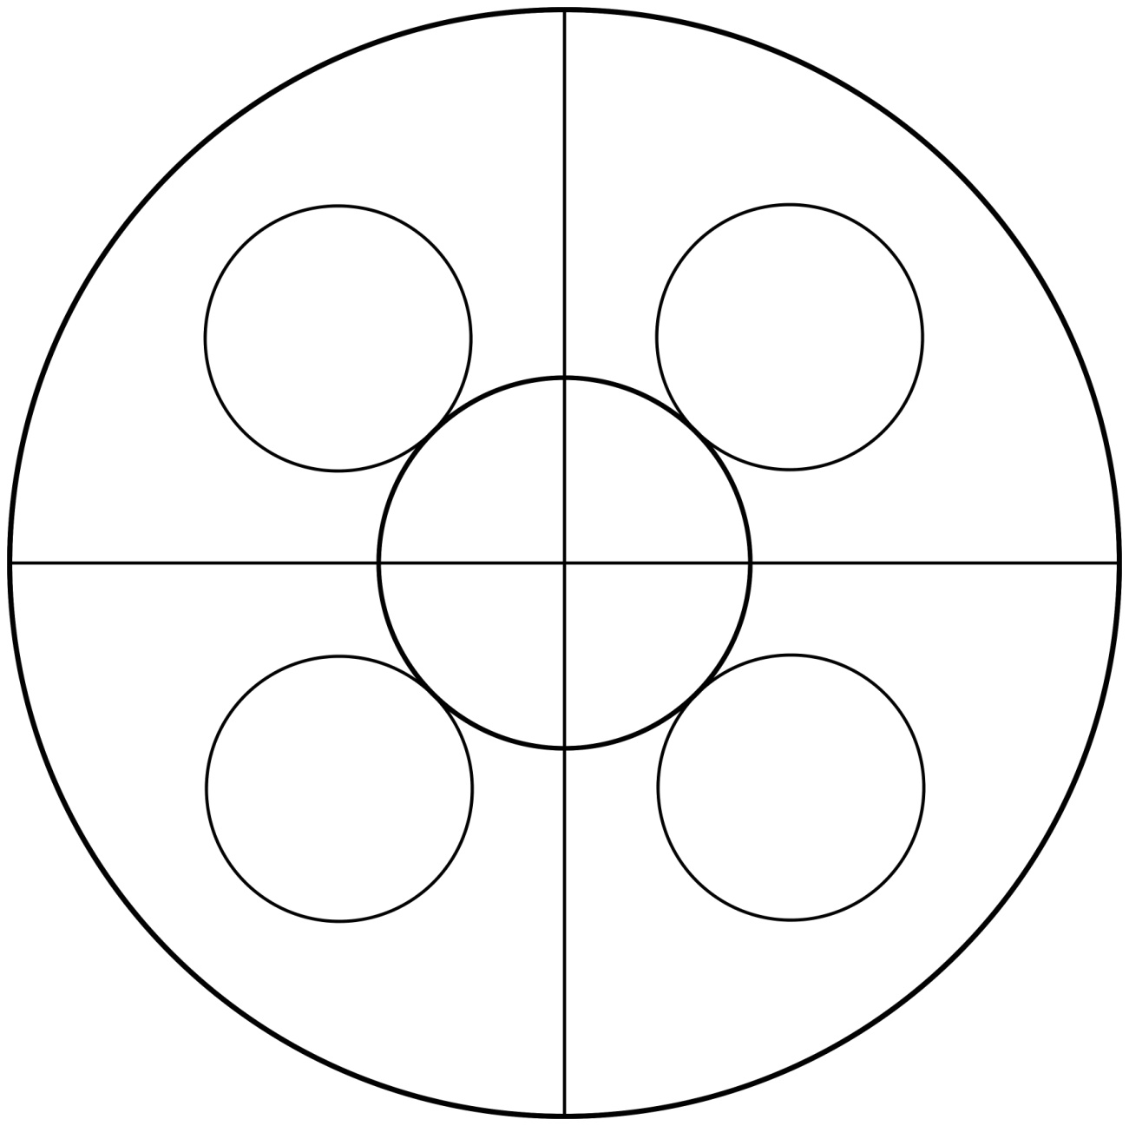

**[android-mandalas](https://play.google.com/store/apps/details?id=com.crud.mandala.app)**

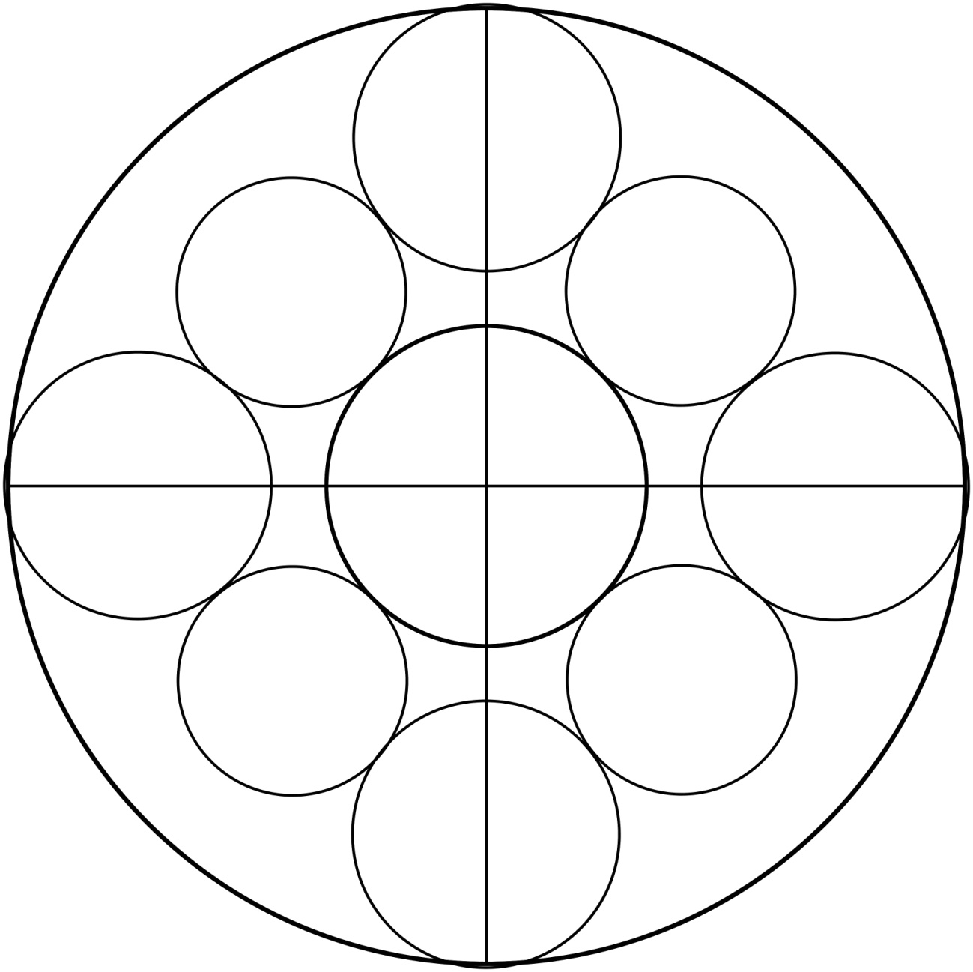

**[android-mandalas](https://play.google.com/store/apps/details?id=com.crud.mandala.app)**

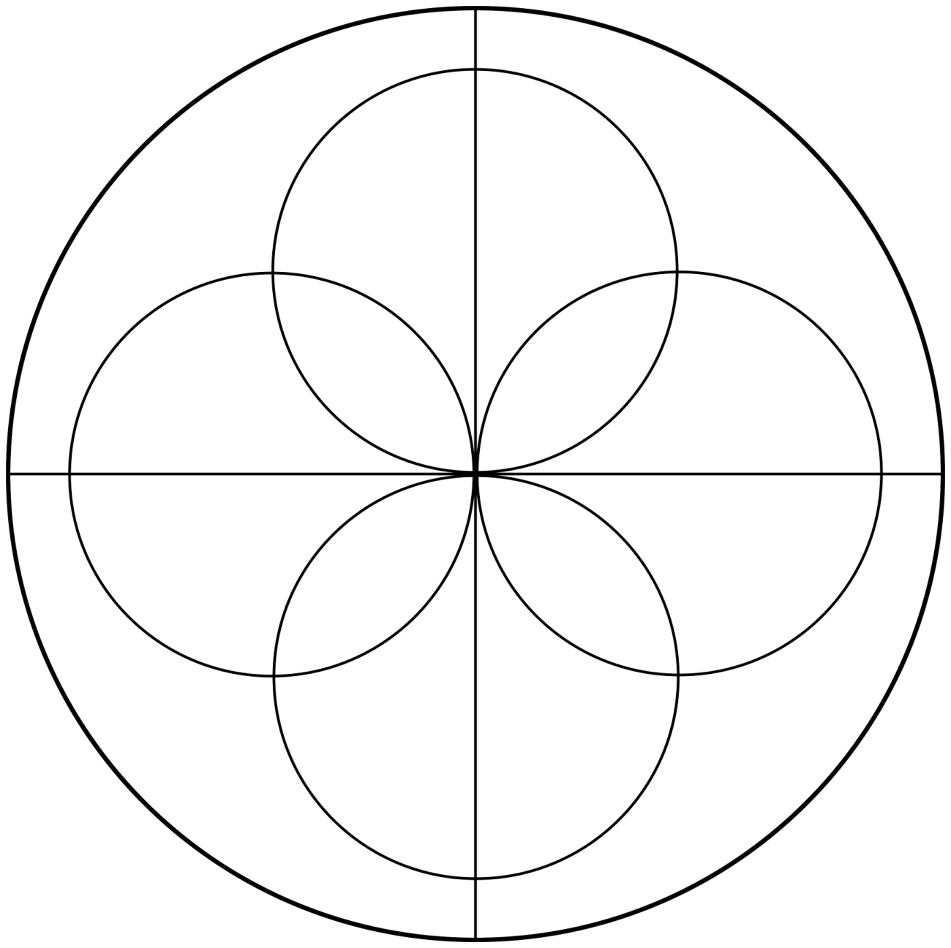

**[android-mandalas](https://play.google.com/store/apps/details?id=com.crud.mandala.app)**

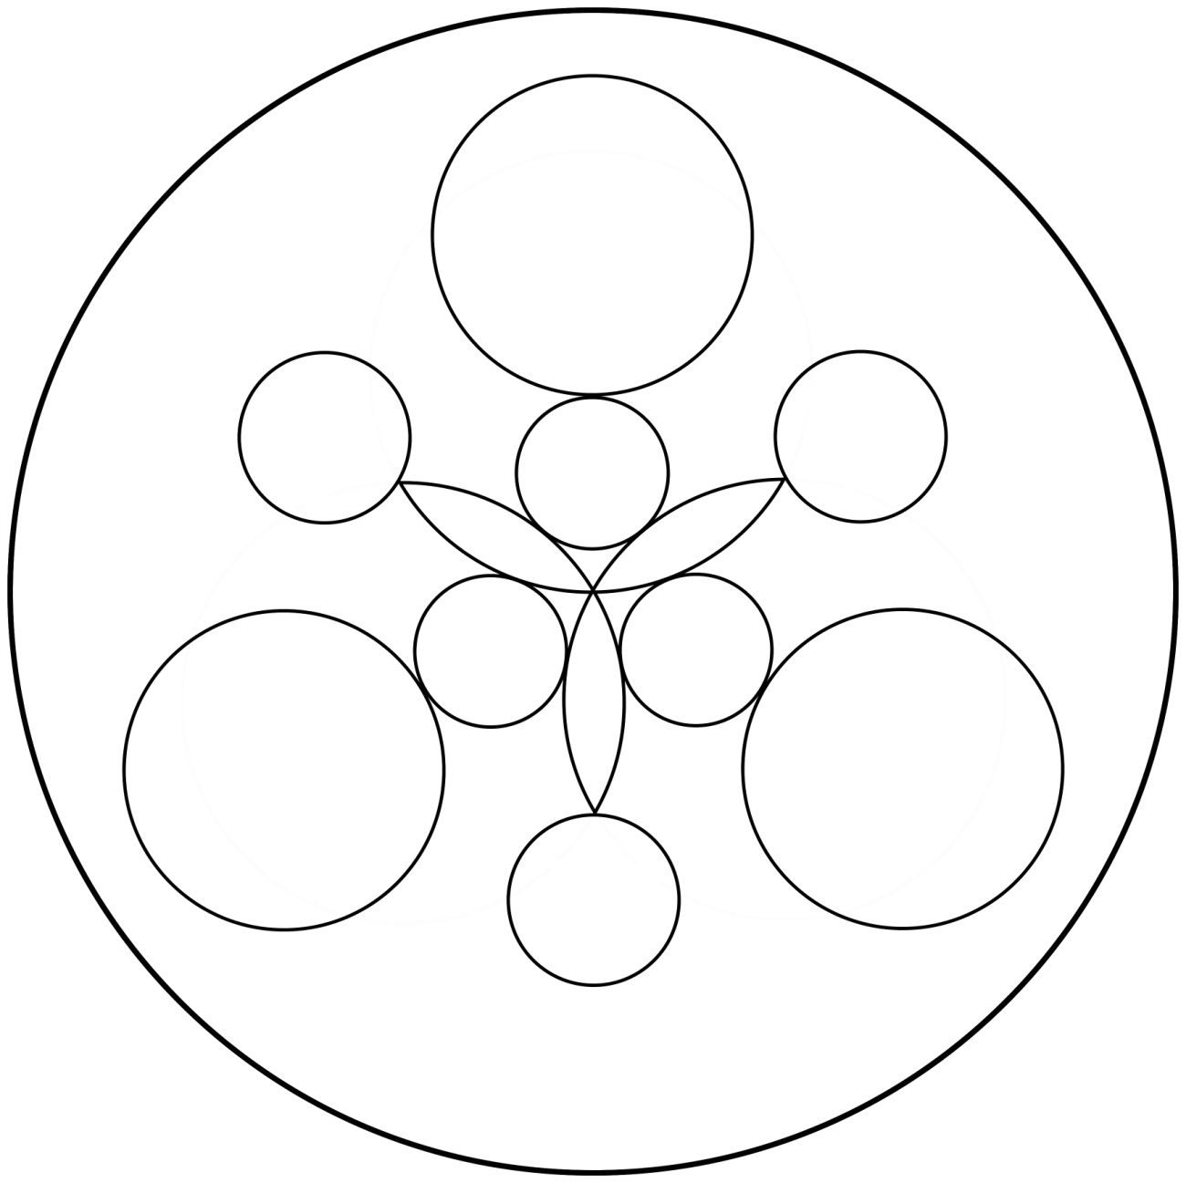

**[android-mandalas](https://play.google.com/store/apps/details?id=com.crud.mandala.app)**

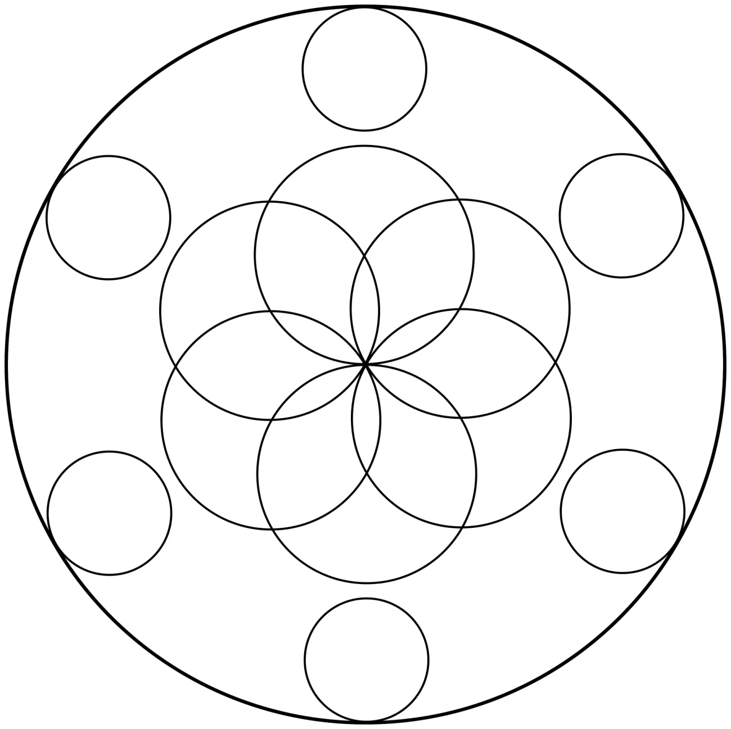

**[android-mandalas](https://play.google.com/store/apps/details?id=com.crud.mandala.app)**

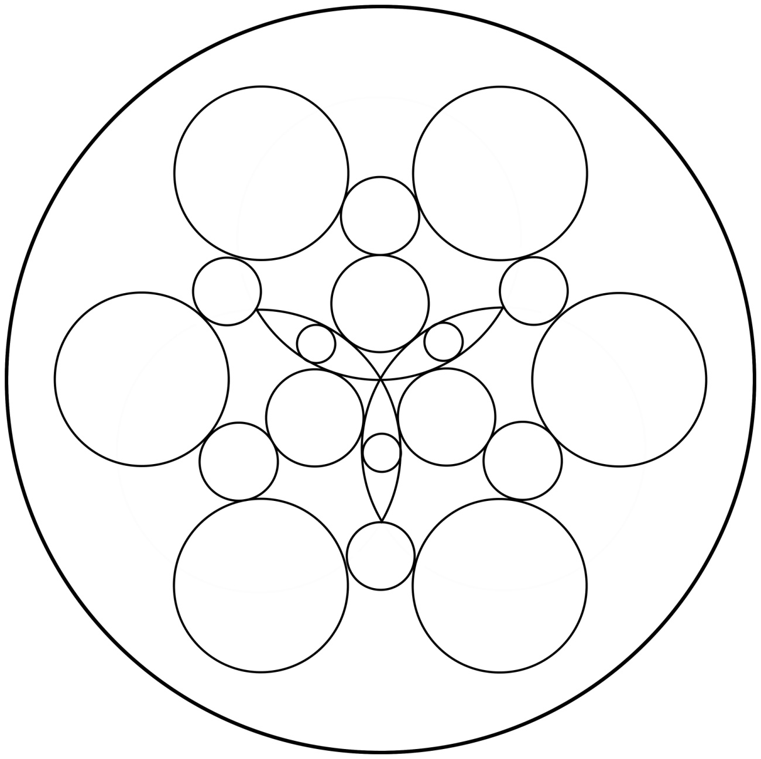

**[android-mandalas](https://play.google.com/store/apps/details?id=com.crud.mandala.app)**

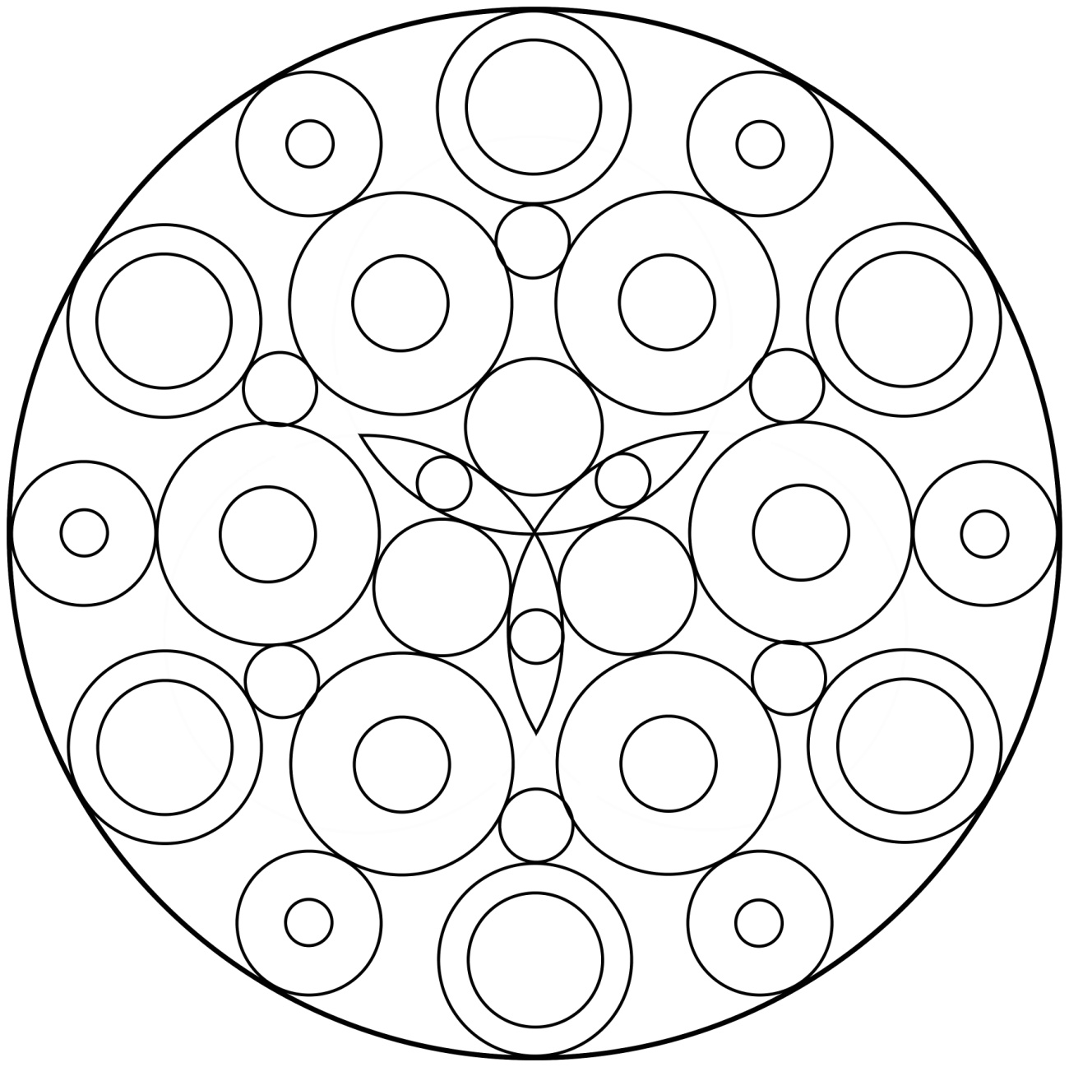

**[android-mandalas](https://play.google.com/store/apps/details?id=com.crud.mandala.app)**

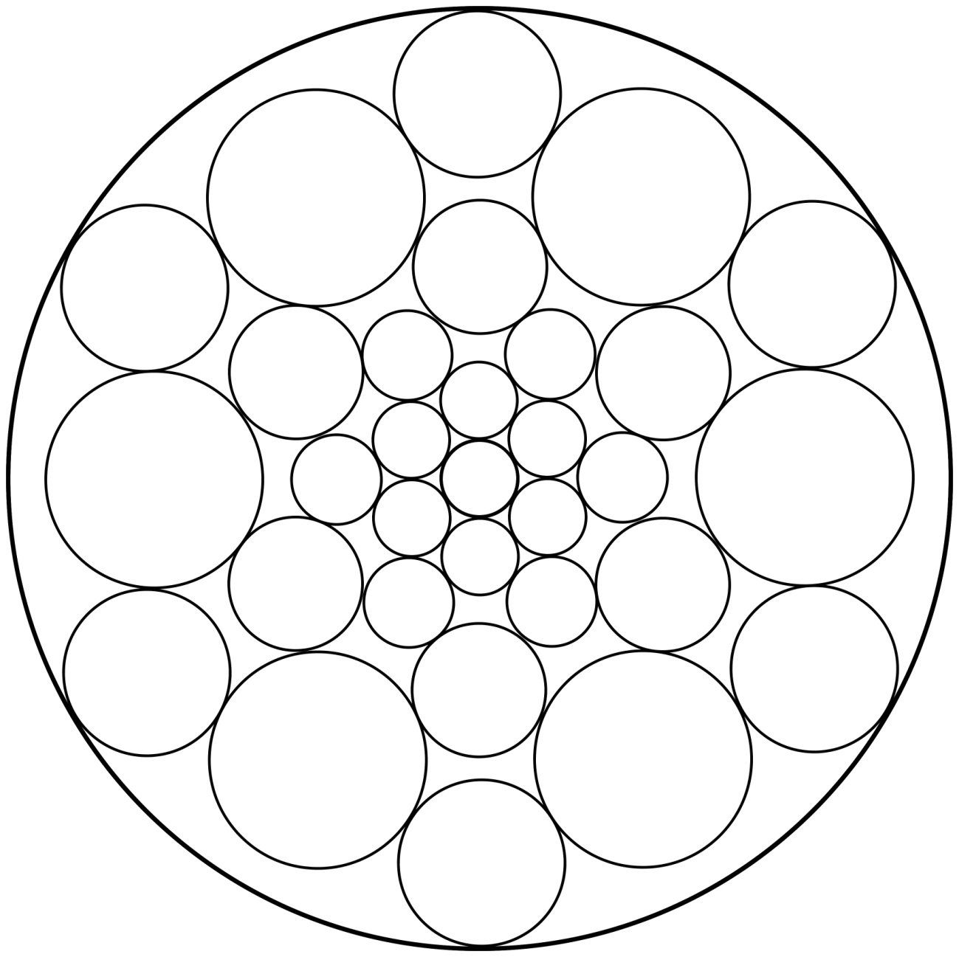

**[android-mandalas](https://play.google.com/store/apps/details?id=com.crud.mandala.app)**

**[android-mandalas](https://play.google.com/store/apps/details?id=com.crud.mandala.app)**