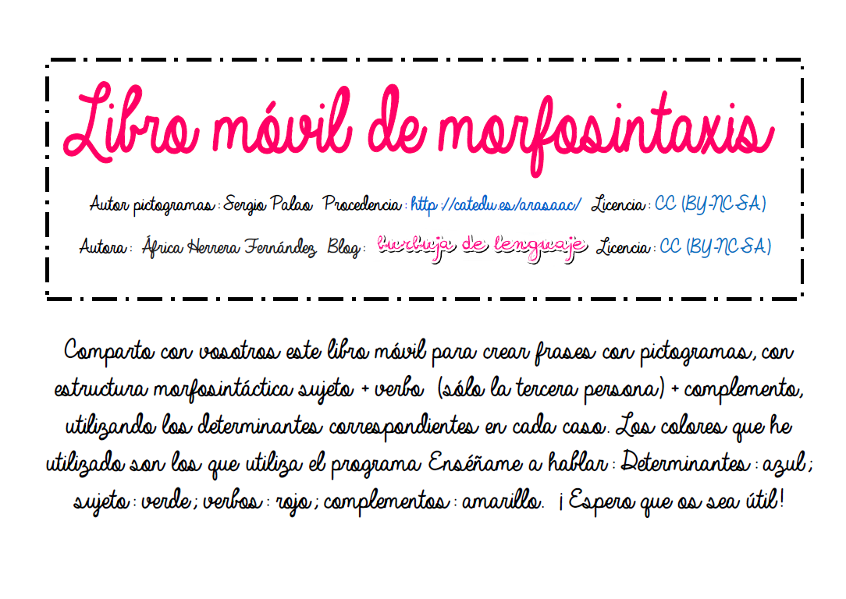

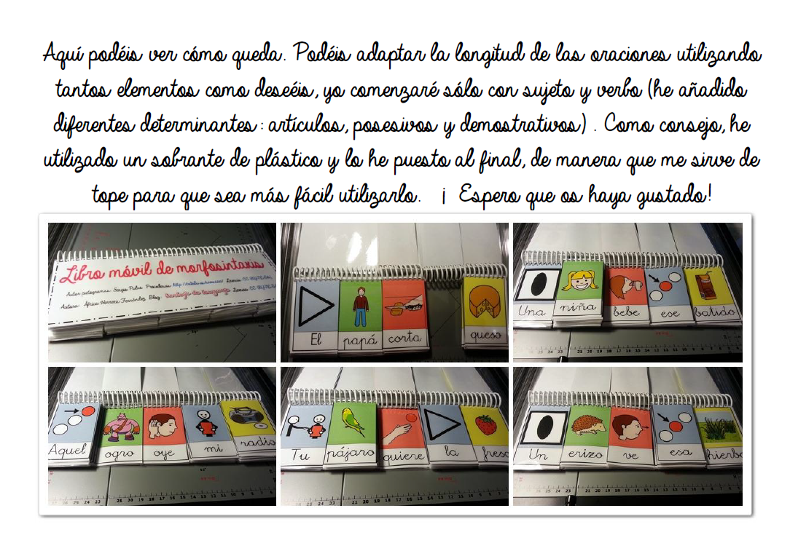

|  |  |  |  |  |
| --- | --- | --- | --- | --- |
| C:\Users\África\Desktop\oie_transparent(2).png | C:\Users\África\Documents\MIS DOCUMENTOS\AL\PICTOGRAMAS ARASAAC\Pictogramas_Color_completo ARASAAC\hombre_1.png | C:\Users\África\Desktop\oie_transparent.png | C:\Users\África\Desktop\oie_transparent(2).png | C:\Users\África\Documents\MIS DOCUMENTOS\AL\PICTOGRAMAS ARASAAC\Pictogramas_Color_completo ARASAAC\pan blanco.png |
| El | papá | come | el | pan |

|  |  |  |  |  |
| --- | --- | --- | --- | --- |
| C:\Users\África\Desktop\oie_transparent(2).png | mujer_2 | C:\Users\África\Desktop\oie_transparent(1).png | C:\Users\África\Desktop\oie_transparent(2).png | C:\Users\África\Documents\MIS DOCUMENTOS\AL\PICTOGRAMAS ARASAAC\Pictogramas_Color_completo ARASAAC\galletas_2.png |
| La | mamá | come | la | galleta |

|  |  |  |  |  |
| --- | --- | --- | --- | --- |
| C:\Users\África\Documents\MIS DOCUMENTOS\AL\PICTOGRAMAS ARASAAC\Pictogramas_Color_completo ARASAAC\un.png | C:\Users\África\Documents\MIS DOCUMENTOS\AL\PICTOGRAMAS ARASAAC\Pictogramas_Color_completo ARASAAC\abuelo.png | C:\Users\África\Documents\MIS DOCUMENTOS\AL\PICTOGRAMAS ARASAAC\Pictogramas_Color_completo ARASAAC\beber.png | C:\Users\África\Documents\MIS DOCUMENTOS\AL\PICTOGRAMAS ARASAAC\Pictogramas_Color_completo ARASAAC\un.png | C:\Users\África\Desktop\oie_transparent.png |
| Un | abuelo | bebe | un | leche |

|  |  |  |  |  |
| --- | --- | --- | --- | --- |
| C:\Users\África\Documents\MIS DOCUMENTOS\AL\PICTOGRAMAS ARASAAC\Pictogramas_Color_completo ARASAAC\un.png | C:\Users\África\Documents\MIS DOCUMENTOS\AL\PICTOGRAMAS ARASAAC\Pictogramas_Color_completo ARASAAC\abuela_1.png | C:\Users\África\Documents\MIS DOCUMENTOS\AL\PICTOGRAMAS ARASAAC\Pictogramas_Color_completo ARASAAC\beber (2).png | C:\Users\África\Documents\MIS DOCUMENTOS\AL\PICTOGRAMAS ARASAAC\Pictogramas_Color_completo ARASAAC\un.png | C:\Users\África\Documents\MIS DOCUMENTOS\AL\PICTOGRAMAS ARASAAC\Pictogramas_Color_completo ARASAAC\café.png |
| Una | abuela | bebe | una | café |

|  |  |  |  |  |
| --- | --- | --- | --- | --- |
| C:\Users\África\Desktop\oie_transparent(5).png | C:\Users\África\Documents\MIS DOCUMENTOS\AL\PICTOGRAMAS ARASAAC\Pictogramas_Color_completo ARASAAC\gatear.png | C:\Users\África\Documents\MIS DOCUMENTOS\AL\PICTOGRAMAS ARASAAC\Pictogramas_Color_completo ARASAAC\ver_2.png | C:\Users\África\Desktop\oie_transparent(5).png | C:\Users\África\Desktop\oie_transparent(1).png |
| Mi | bebé | ve | mi | pato |

|  |  |  |  |  |
| --- | --- | --- | --- | --- |
| C:\Users\África\Desktop\tu.png | C:\Users\África\Desktop\oie_transparent(2).png | C:\Users\África\Documents\MIS DOCUMENTOS\AL\PICTOGRAMAS ARASAAC\Pictogramas_Color_completo ARASAAC\ver_4.png | C:\Users\África\Desktop\tu.png | C:\Users\África\Documents\MIS DOCUMENTOS\AL\PICTOGRAMAS ARASAAC\Pictogramas_Color_completo ARASAAC\queso_1.png |
| Tu | niña | ve | tu | queso |
| C:\Users\África\Desktop\su.png | C:\Users\África\Desktop\oie_transparent(3).png | C:\Users\África\Documents\MIS DOCUMENTOS\AL\PICTOGRAMAS ARASAAC\Pictogramas_Color_completo ARASAAC\oír.png | C:\Users\África\Desktop\su.png | C:\Users\África\Desktop\oie_transparent.png |
| Su | niño | oye | su | radio |

|  |  |  |  |  |
| --- | --- | --- | --- | --- |
| C:\Users\África\Desktop\oie_transparent(3).png | C:\Users\África\Documents\MIS DOCUMENTOS\AL\PICTOGRAMAS ARASAAC\Pictogramas_Color_completo ARASAAC\gato.png | C:\Users\África\Documents\MIS DOCUMENTOS\AL\PICTOGRAMAS ARASAAC\Pictogramas_Color_completo ARASAAC\oír_2.png | C:\Users\África\Desktop\oie_transparent(3).png | C:\Users\África\Documents\MIS DOCUMENTOS\AL\PICTOGRAMAS ARASAAC\Pictogramas_Color_completo ARASAAC\agua_4.png |
| Este | gato | oye | este | agua |

|  |  |  |  |  |
| --- | --- | --- | --- | --- |
| C:\Users\África\Desktop\oie_transparent(3).png | C:\Users\África\Documents\MIS DOCUMENTOS\AL\PICTOGRAMAS ARASAAC\Pictogramas_Color_completo ARASAAC\perro.png | C:\Users\África\Documents\MIS DOCUMENTOS\AL\PICTOGRAMAS ARASAAC\Pictogramas_Color_completo ARASAAC\oler_1.png | C:\Users\África\Desktop\oie_transparent(3).png | C:\Users\África\Documents\MIS DOCUMENTOS\AL\PICTOGRAMAS ARASAAC\Pictogramas_Color_completo ARASAAC\flor_1.png |
| Esta | perro | huele | esta | flor |

|  |  |  |  |  |
| --- | --- | --- | --- | --- |
| C:\Users\África\Desktop\oie_transparent(2).png | C:\Users\África\Documents\MIS DOCUMENTOS\AL\PICTOGRAMAS ARASAAC\Pictogramas_Color_completo ARASAAC\conejo.png | C:\Users\África\Documents\MIS DOCUMENTOS\AL\PICTOGRAMAS ARASAAC\Pictogramas_Color_completo ARASAAC\oler (2).png | C:\Users\África\Desktop\oie_transparent(2).png | C:\Users\África\Desktop\oie_transparent(1).png |
| Ese | conejo | huele | ese | tarta |

|  |  |  |  |  |
| --- | --- | --- | --- | --- |
| C:\Users\África\Desktop\oie_transparent(2).png | C:\Users\África\Desktop\oie_transparent.png | C:\Users\África\Desktop\oie_transparent.png | C:\Users\África\Desktop\oie_transparent(2).png | C:\Users\África\Documents\MIS DOCUMENTOS\AL\PICTOGRAMAS ARASAAC\Pictogramas_Color_completo ARASAAC\hierba_1.png |
| Esa | vaca | dibuja | esa | hierba |

|  |  |  |  |  |
| --- | --- | --- | --- | --- |
| C:\Users\África\Desktop\oie_transparent(3).png | C:\Users\África\Documents\MIS DOCUMENTOS\AL\PICTOGRAMAS ARASAAC\Pictogramas_Color_completo ARASAAC\gallo_2.png | C:\Users\África\Desktop\oie_transparent(1).png | C:\Users\África\Desktop\oie_transparent(3).png | C:\Users\África\Documents\MIS DOCUMENTOS\AL\PICTOGRAMAS ARASAAC\Pictogramas_Color_completo ARASAAC\helado_2.png |
| Aquel | gallo | corta | aquel | helado |

|  |  |  |  |  |
| --- | --- | --- | --- | --- |
| C:\Users\África\Desktop\oie_transparent(3).png | C:\Users\África\Desktop\oie_transparent(2).png | C:\Users\África\Desktop\oie_transparent(3).png | C:\Users\África\Desktop\oie_transparent(3).png | C:\Users\África\Documents\MIS DOCUMENTOS\AL\PICTOGRAMAS ARASAAC\Pictogramas_Color_completo ARASAAC\sopa_4.png |
| Aquella | ratón | quiere | aquella | sopa |

|  |  |  |  |  |
| --- | --- | --- | --- | --- |
| C:\Users\África\Desktop\oie_transparent(2).png | C:\Users\África\Documents\MIS DOCUMENTOS\AL\PICTOGRAMAS ARASAAC\Pictogramas_Color_completo ARASAAC\periquito.png | C:\Users\África\Documents\MIS DOCUMENTOS\AL\PICTOGRAMAS ARASAAC\Pictogramas_Color_completo ARASAAC\romper.png | C:\Users\África\Desktop\oie_transparent(2).png | C:\Users\África\Documents\MIS DOCUMENTOS\AL\PICTOGRAMAS ARASAAC\Pictogramas_Color_completo ARASAAC\silla de cocina.png |
| El | pájaro | rompe | el | silla |
| C:\Users\África\Desktop\oie_transparent(2).png | C:\Users\África\Desktop\oie_transparent(4).png | C:\Users\África\Desktop\oie_transparent(5).png | C:\Users\África\Desktop\oie_transparent(2).png | C:\Users\África\Documents\MIS DOCUMENTOS\AL\PICTOGRAMAS ARASAAC\Pictogramas_Color_completo ARASAAC\fresa.png |
| La | pez | coge | la | fresa |

|  |  |  |  |  |
| --- | --- | --- | --- | --- |
| C:\Users\África\Documents\MIS DOCUMENTOS\AL\PICTOGRAMAS ARASAAC\Pictogramas_Color_completo ARASAAC\un.png | C:\Users\África\Documents\MIS DOCUMENTOS\AL\PICTOGRAMAS ARASAAC\Pictogramas_Color_completo ARASAAC\rana_1.png | C:\Users\África\Documents\MIS DOCUMENTOS\AL\PICTOGRAMAS ARASAAC\Pictogramas_Color_completo ARASAAC\tener.png | C:\Users\África\Documents\MIS DOCUMENTOS\AL\PICTOGRAMAS ARASAAC\Pictogramas_Color_completo ARASAAC\un.png | C:\Users\África\Desktop\oie_transparent(6).png |
| Un | rana | tiene | un | batido |

|  |  |  |  |  |
| --- | --- | --- | --- | --- |
| C:\Users\África\Documents\MIS DOCUMENTOS\AL\PICTOGRAMAS ARASAAC\Pictogramas_Color_completo ARASAAC\un.png | C:\Users\África\Documents\MIS DOCUMENTOS\AL\PICTOGRAMAS ARASAAC\Pictogramas_Color_completo ARASAAC\erizo.png | C:\Users\África\Documents\MIS DOCUMENTOS\AL\PICTOGRAMAS ARASAAC\Pictogramas_Color_completo ARASAAC\tirar_11.png | C:\Users\África\Documents\MIS DOCUMENTOS\AL\PICTOGRAMAS ARASAAC\Pictogramas_Color_completo ARASAAC\un.png | C:\Users\África\Desktop\oie_transparent(7).png |
| Una | erizo | tira | una | huevo |

|  |  |  |  |  |
| --- | --- | --- | --- | --- |
| C:\Users\África\Desktop\oie_transparent(5).png | C:\Users\África\Desktop\joven.png | C:\Users\África\Desktop\oie_transparent.png | C:\Users\África\Desktop\oie_transparent(5).png | C:\Users\África\Desktop\oie_transparent(8).png |
| Mi | prima | come | mi | yogur |

|  |  |  |  |  |
| --- | --- | --- | --- | --- |
| C:\Users\África\Desktop\tu.png | C:\Users\África\Desktop\joven(1).png | C:\Users\África\Desktop\oie_transparent(1).png | C:\Users\África\Desktop\tu.png | C:\Users\África\Documents\MIS DOCUMENTOS\AL\PICTOGRAMAS ARASAAC\ALIMENTOS\flan_1.png |
| Tu | primo | come | tu | flan |

|  |  |  |  |  |
| --- | --- | --- | --- | --- |
| C:\Users\África\Desktop\su.png | C:\Users\África\Documents\MIS DOCUMENTOS\AL\PICTOGRAMAS ARASAAC\Pictogramas_Color_completo ARASAAC\Lobo Feroz.png | C:\Users\África\Documents\MIS DOCUMENTOS\AL\PICTOGRAMAS ARASAAC\Pictogramas_Color_completo ARASAAC\beber.png | C:\Users\África\Desktop\su.png | C:\Users\África\Documents\MIS DOCUMENTOS\AL\PICTOGRAMAS ARASAAC\ALIMENTOS\zumo de naranja.png |
| Su | lobo | bebe | su | zumo |

|  |  |  |  |  |
| --- | --- | --- | --- | --- |
| C:\Users\África\Desktop\su.png | C:\Users\África\Documents\MIS DOCUMENTOS\AL\PICTOGRAMAS ARASAAC\Pictogramas_Color_completo ARASAAC\hada.png | C:\Users\África\Documents\MIS DOCUMENTOS\AL\PICTOGRAMAS ARASAAC\Pictogramas_Color_completo ARASAAC\beber (2).png | C:\Users\África\Desktop\oie_transparent(3).png | C:\Users\África\Documents\MIS DOCUMENTOS\AL\PICTOGRAMAS ARASAAC\ALIMENTOS\leche con cacao.png |
| Este | hada | bebe | este | cacao |

|  |  |  |  |  |
| --- | --- | --- | --- | --- |
| C:\Users\África\Desktop\oie_transparent(3).png | C:\Users\África\Documents\MIS DOCUMENTOS\AL\PICTOGRAMAS ARASAAC\Pictogramas_Color_completo ARASAAC\Gato con botas.png | C:\Users\África\Documents\MIS DOCUMENTOS\AL\PICTOGRAMAS ARASAAC\Pictogramas_Color_completo ARASAAC\ver_2.png | C:\Users\África\Desktop\oie_transparent(3).png | C:\Users\África\Desktop\oie_transparent(4).png |
| Esta | gato | ve | esta | coche |

|  |  |  |  |  |
| --- | --- | --- | --- | --- |
| C:\Users\África\Desktop\oie_transparent(2).png | C:\Users\África\Desktop\oie_transparent(9).png | C:\Users\África\Documents\MIS DOCUMENTOS\AL\PICTOGRAMAS ARASAAC\Pictogramas_Color_completo ARASAAC\ver_4.png | C:\Users\África\Desktop\oie_transparent(2).png | C:\Users\África\Documents\MIS DOCUMENTOS\AL\PICTOGRAMAS ARASAAC\Pictogramas_Color_completo ARASAAC\sapo.png |
| Ese | bruja | ve | ese | sapo |

|  |  |  |  |  |
| --- | --- | --- | --- | --- |
| C:\Users\África\Desktop\oie_transparent(2).png | C:\Users\África\Desktop\oie_transparent(5).png | C:\Users\África\Documents\MIS DOCUMENTOS\AL\PICTOGRAMAS ARASAAC\Pictogramas_Color_completo ARASAAC\oír.png | C:\Users\África\Desktop\oie_transparent(2).png | C:\Users\África\Documents\MIS DOCUMENTOS\AL\PICTOGRAMAS ARASAAC\Pictogramas_Color_completo ARASAAC\cerdo.png |
| Esa | brujo | oye | esa | cerdo |

|  |  |  |  |  |
| --- | --- | --- | --- | --- |
| C:\Users\África\Desktop\oie_transparent(3).png | C:\Users\África\Desktop\oie_transparent(10).png | C:\Users\África\Desktop\oie_transparent(6).png | C:\Users\África\Desktop\oie_transparent(3).png | C:\Users\África\Documents\MIS DOCUMENTOS\AL\PICTOGRAMAS ARASAAC\Pictogramas_Color_completo ARASAAC\pito.png |
| Aquel | enano | oye | aquel | pito |

|  |  |  |  |  |
| --- | --- | --- | --- | --- |
| C:\Users\África\Desktop\oie_transparent(3).png | C:\Users\África\Documents\MIS DOCUMENTOS\AL\PICTOGRAMAS ARASAAC\Pictogramas_Color_completo ARASAAC\Cerdito mediano.png | C:\Users\África\Desktop\oie_transparent(3).png | C:\Users\África\Desktop\oie_transparent(3).png | C:\Users\África\Documents\MIS DOCUMENTOS\AL\PICTOGRAMAS ARASAAC\ALIMENTOS\kiwi.png |
| Aquella | cerdo | quiere | aquella | kiwi |

|  |  |  |  |  |
| --- | --- | --- | --- | --- |
| C:\Users\África\Desktop\oie_transparent(2).png | C:\Users\África\Documents\MIS DOCUMENTOS\AL\PICTOGRAMAS ARASAAC\Pictogramas_Color_completo ARASAAC\ogro.png | C:\Users\África\Documents\MIS DOCUMENTOS\AL\PICTOGRAMAS ARASAAC\Pictogramas_Color_completo ARASAAC\ver_2.png | C:\Users\África\Desktop\oie_transparent(2).png | C:\Users\África\Documents\MIS DOCUMENTOS\AL\PICTOGRAMAS ARASAAC\ALIMENTOS\melón.png |
| El | ogro | ve | el | melón |

|  |  |  |  |  |
| --- | --- | --- | --- | --- |
| C:\Users\África\Desktop\oie_transparent(2).png | C:\Users\África\Documents\MIS DOCUMENTOS\AL\PICTOGRAMAS ARASAAC\Pictogramas_Color_completo ARASAAC\sirena.png | C:\Users\África\Documents\MIS DOCUMENTOS\AL\PICTOGRAMAS ARASAAC\Pictogramas_Color_completo ARASAAC\ver_4.png | C:\Users\África\Desktop\oie_transparent(2).png | C:\Users\África\Documents\MIS DOCUMENTOS\AL\PICTOGRAMAS ARASAAC\Pictogramas_Color_completo ARASAAC\mesa_4.png |
| La | sirena | ve | la | mesa |