1. Circle in green the solid elements, in blue the liquid ones and in red the gases.
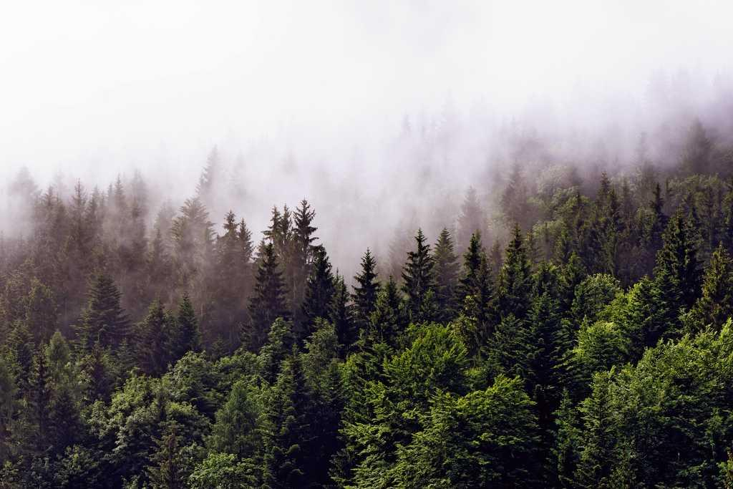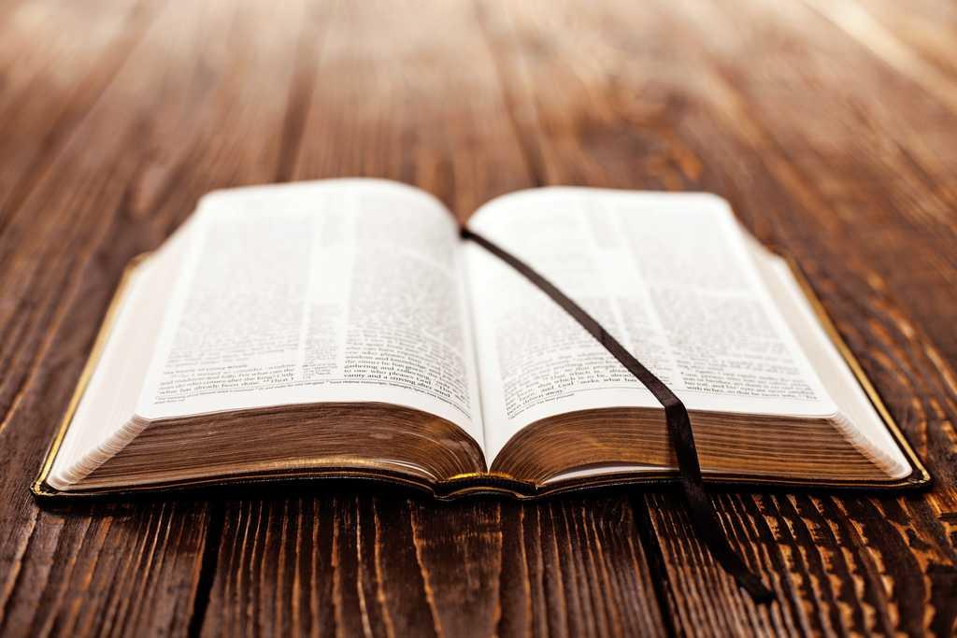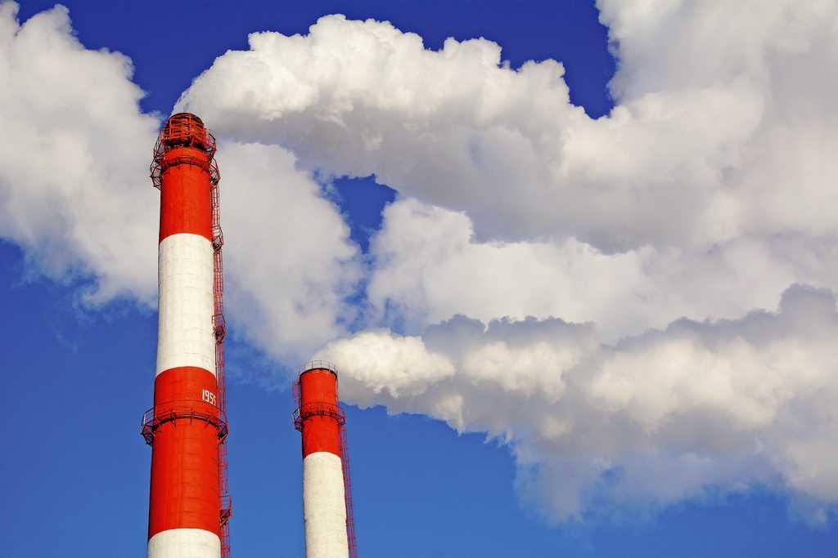
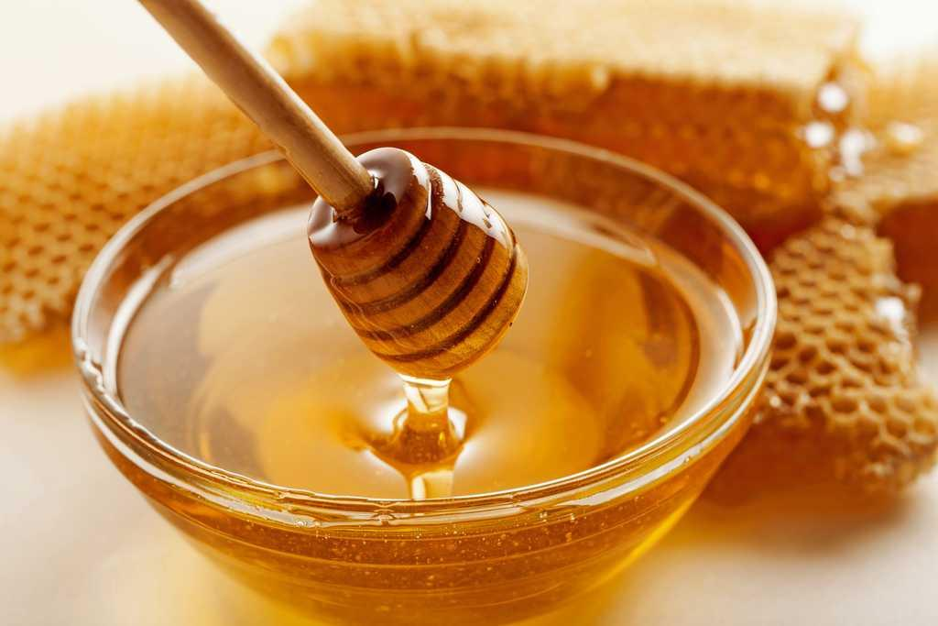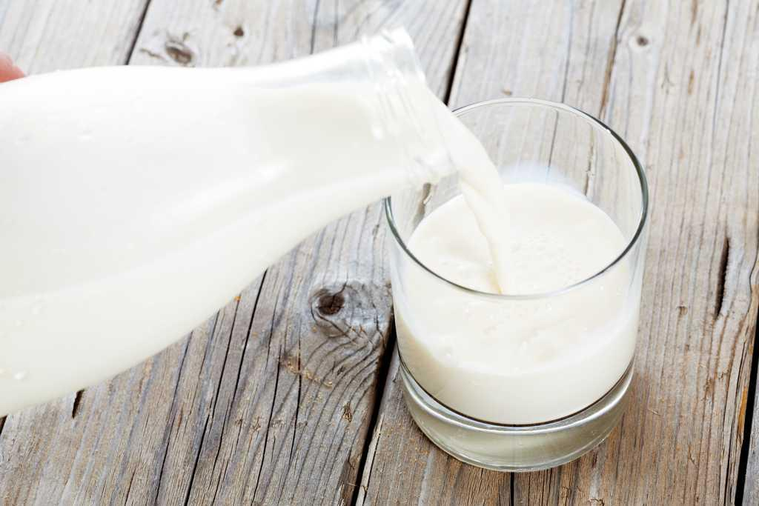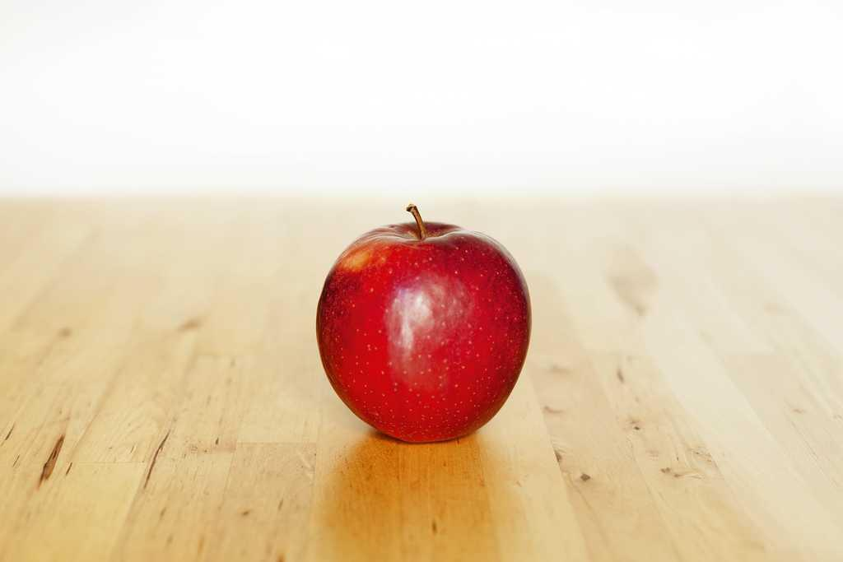

2. Read and complete with the states of matter.
● A has a fixed shape.
● A takes the shape of the container.
● A occupies all the space.

3. Write True (T) or False (F).

● All living things in the Universe are matter.

● All matter has four properties: mass, quantity, volume and shape.

● Volume is the quantity of matter in an object.

4. Read and match.

Wax comes directly from an animal. ●

We make paper from wood. ●

● It is an artificial material.

● It is a natural material.

5. Order these objects from light to heavy. Write numbers 1-3 in the boxes.
2. 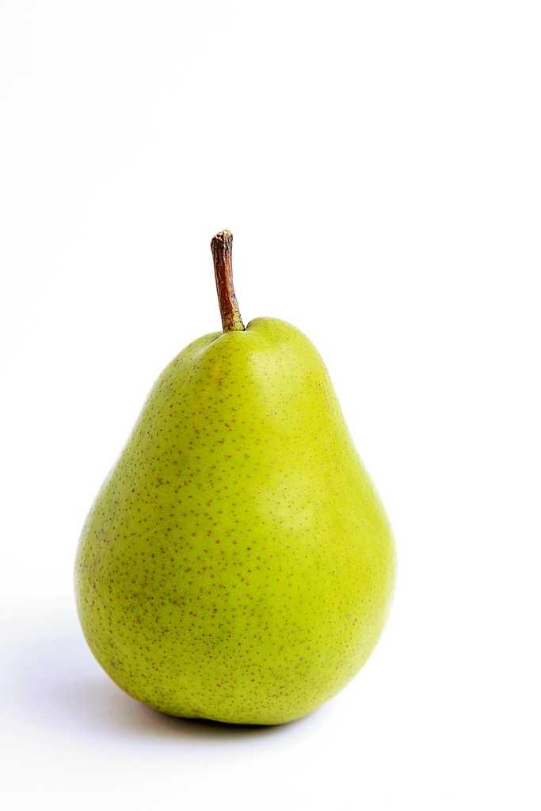
3. 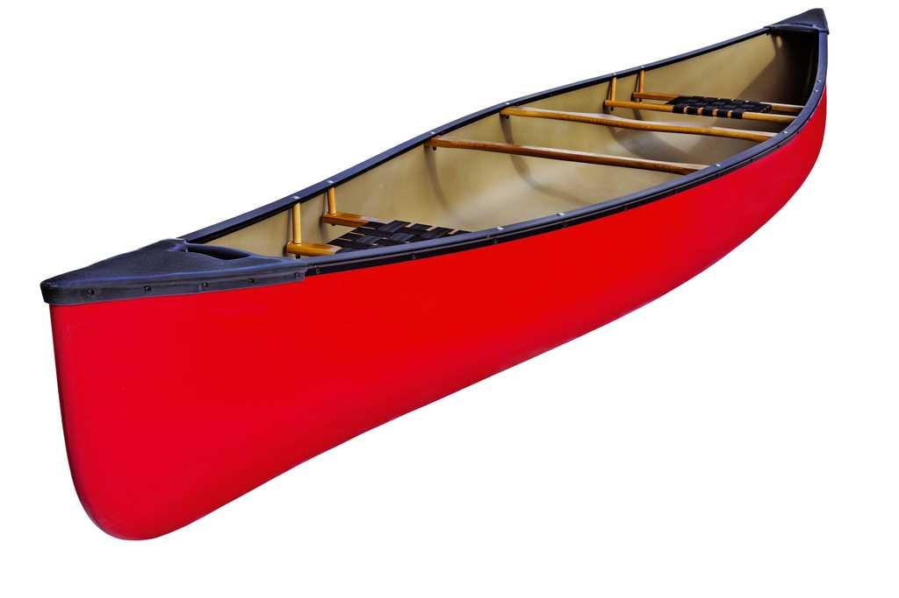
1.

6. Write True (T) or False (F).

● We make pots and pans with plastic.

● We make chairs with wood.

● We make umbrellas with paper.

7. How can we help the environment? Write three words.

8. What materials can you see in these pictures? Classify the words in the boxes.
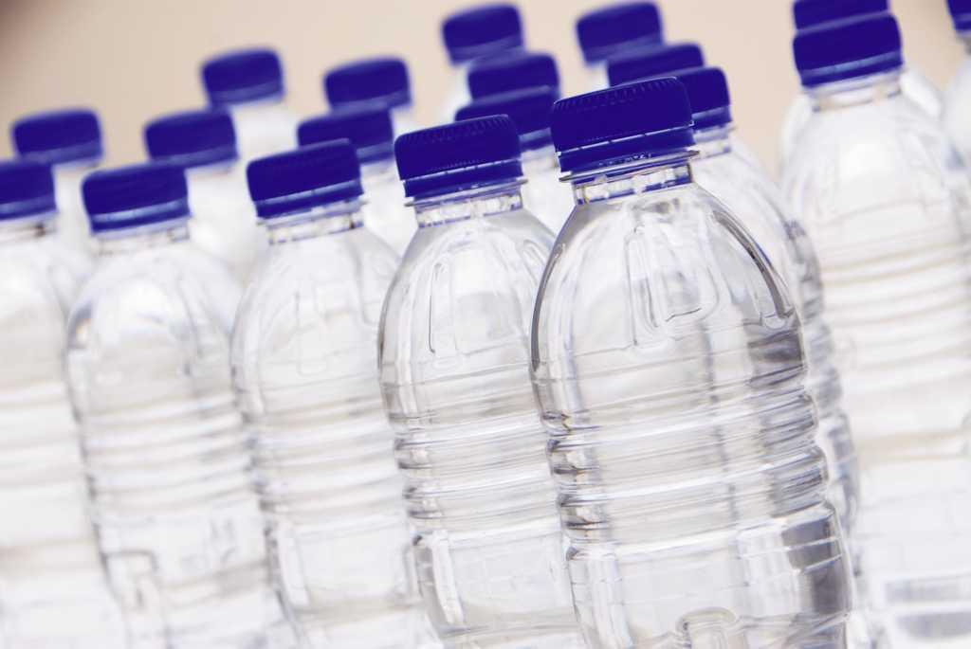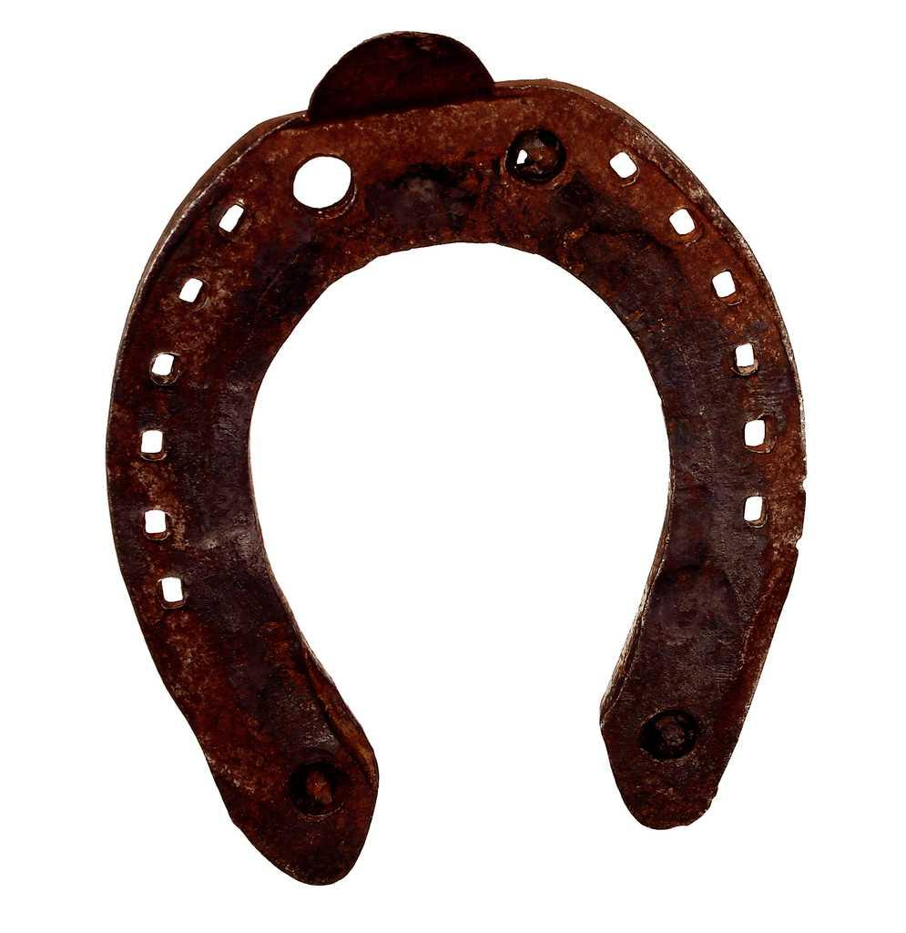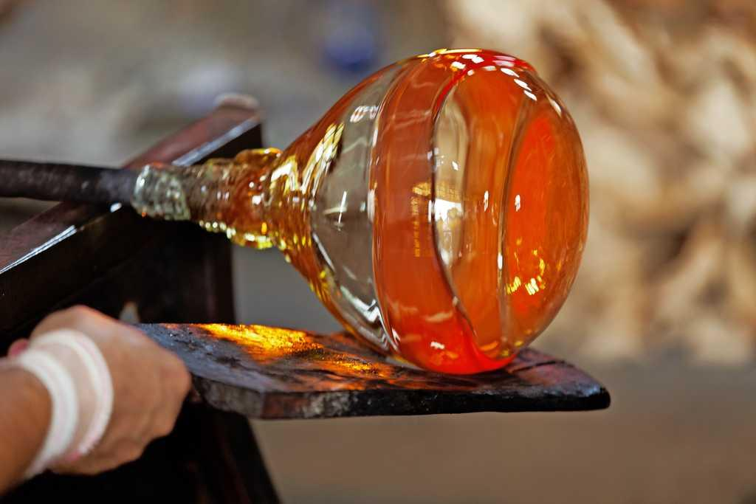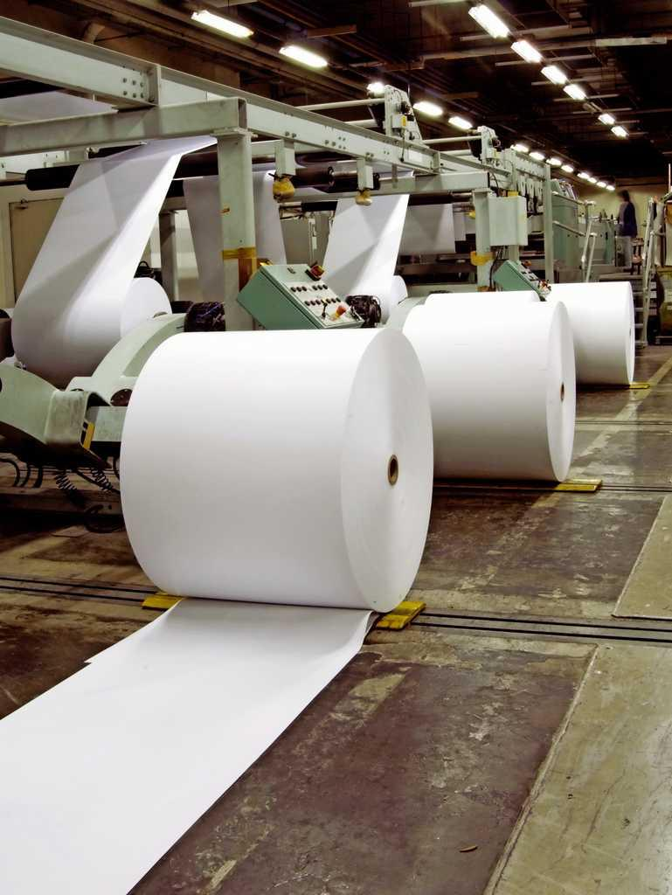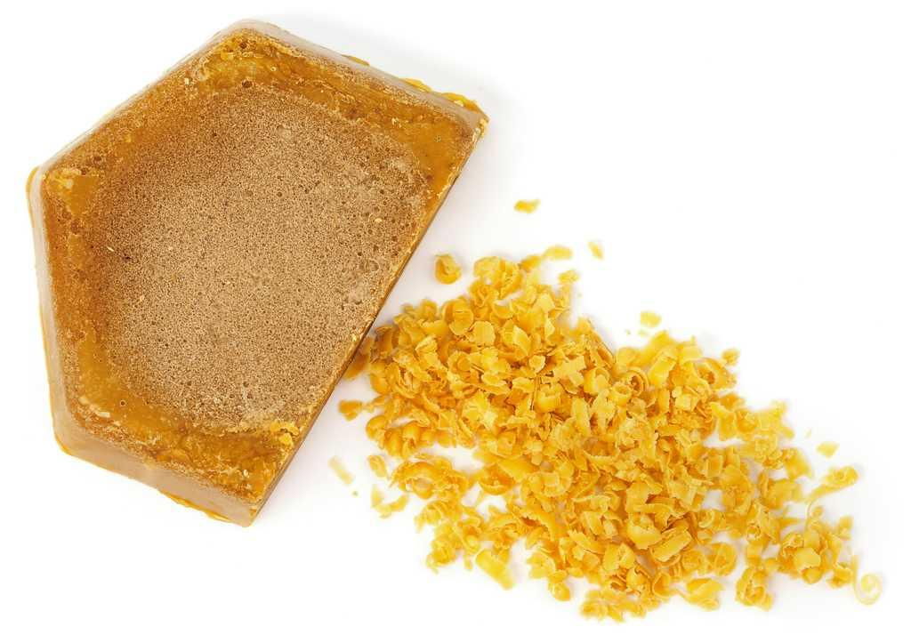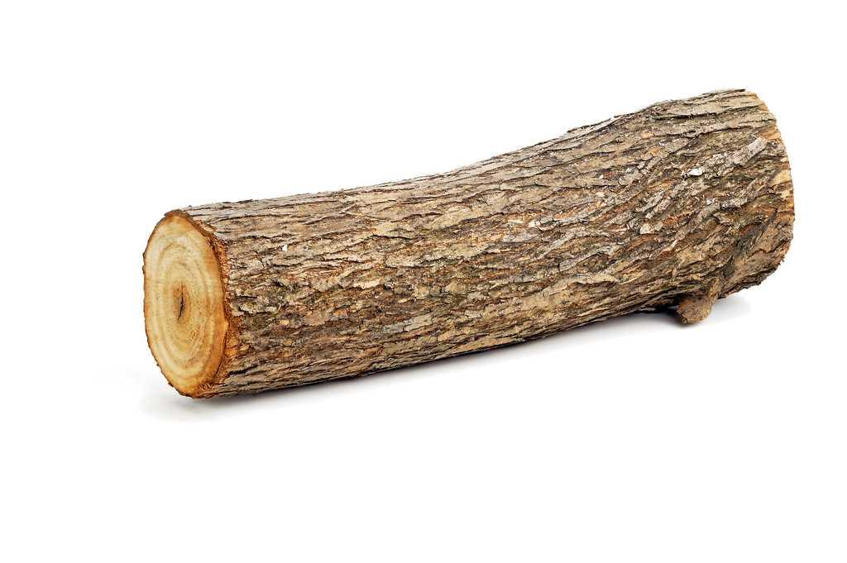

Natural materials | Artificial materials

9. Read and match.

Lever ●

Vacuum cleaner ●

Shears ●

Ramp ●

● We use this for moving objects.

● These use human energy. They are for cutting.

● This needs electricity. It is for cleaning.

● We use this for lifting heavy things.

10. Read and complete.
● find solutions for our different needs.
● are new things. They are constantly improving.
● reduce human effort.

11. Read and match.

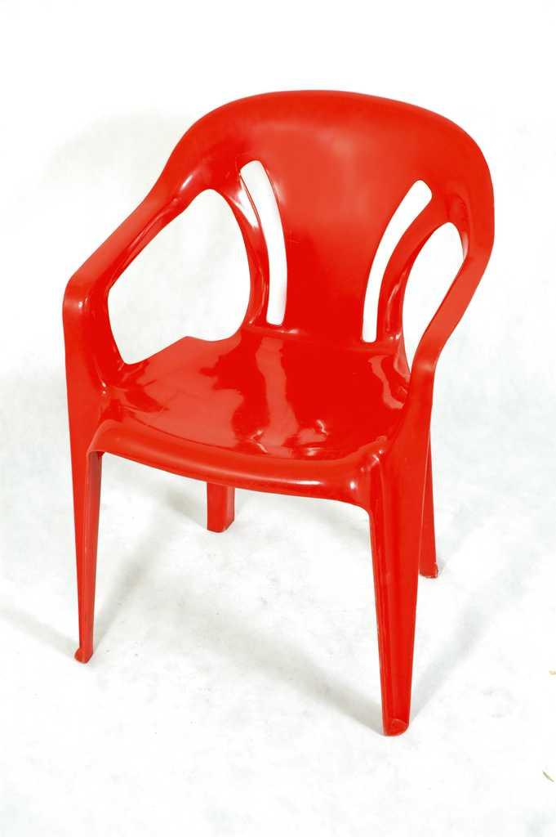 ●
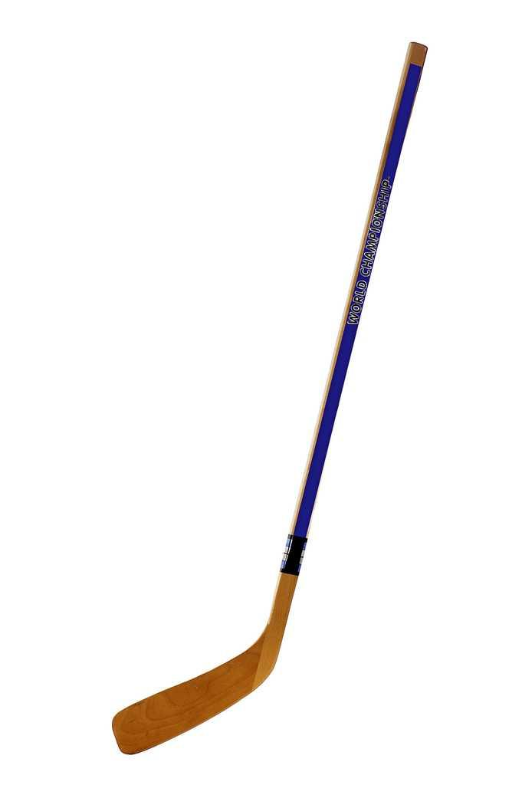 ●
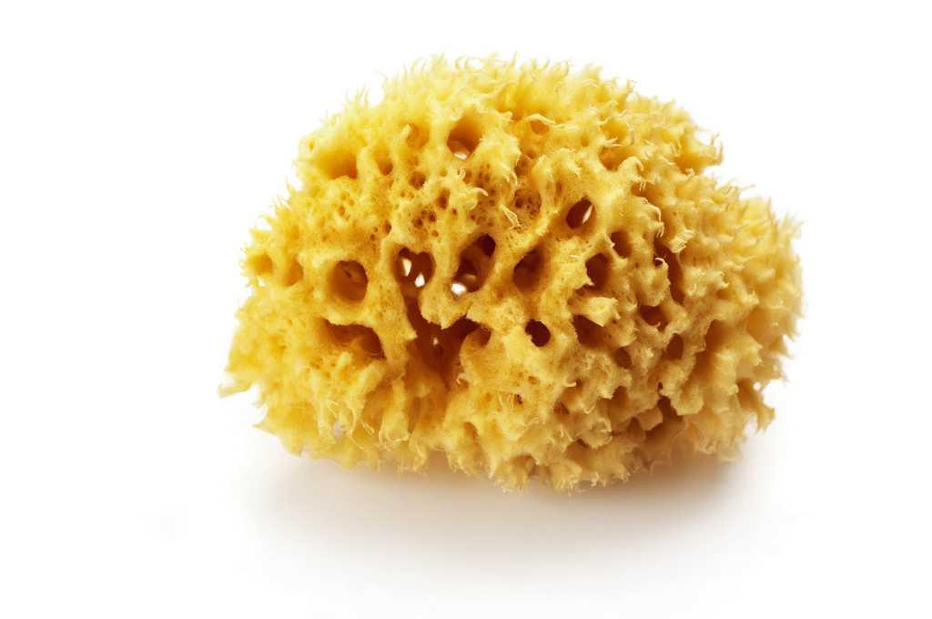 ●
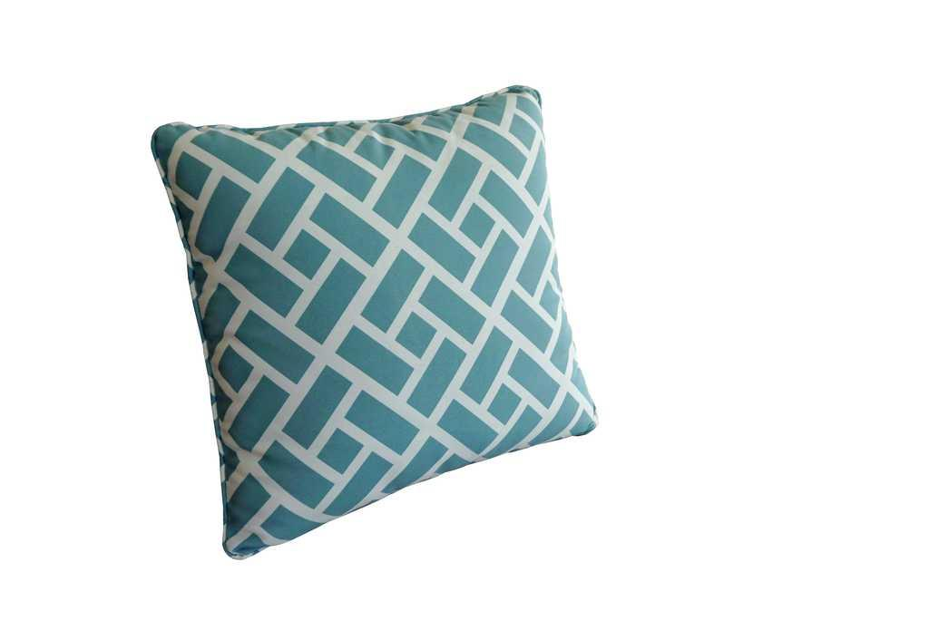 ●
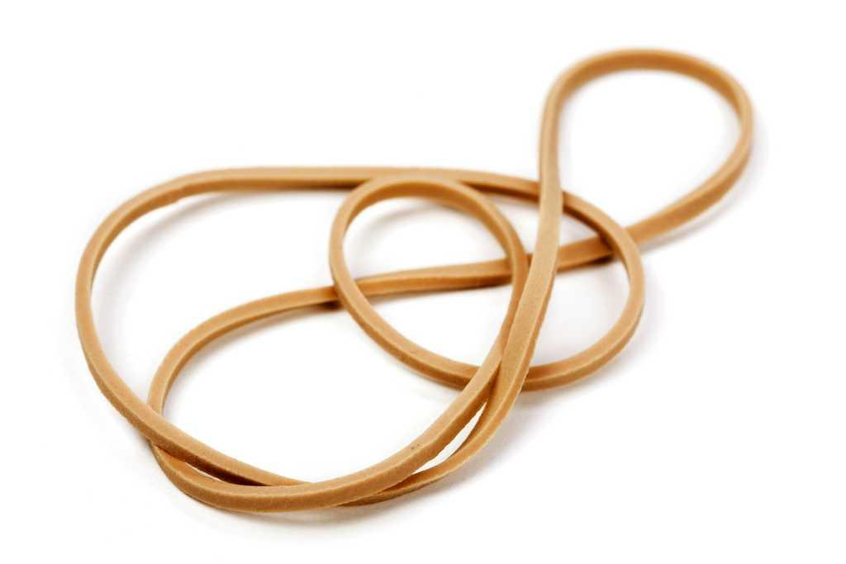 ●
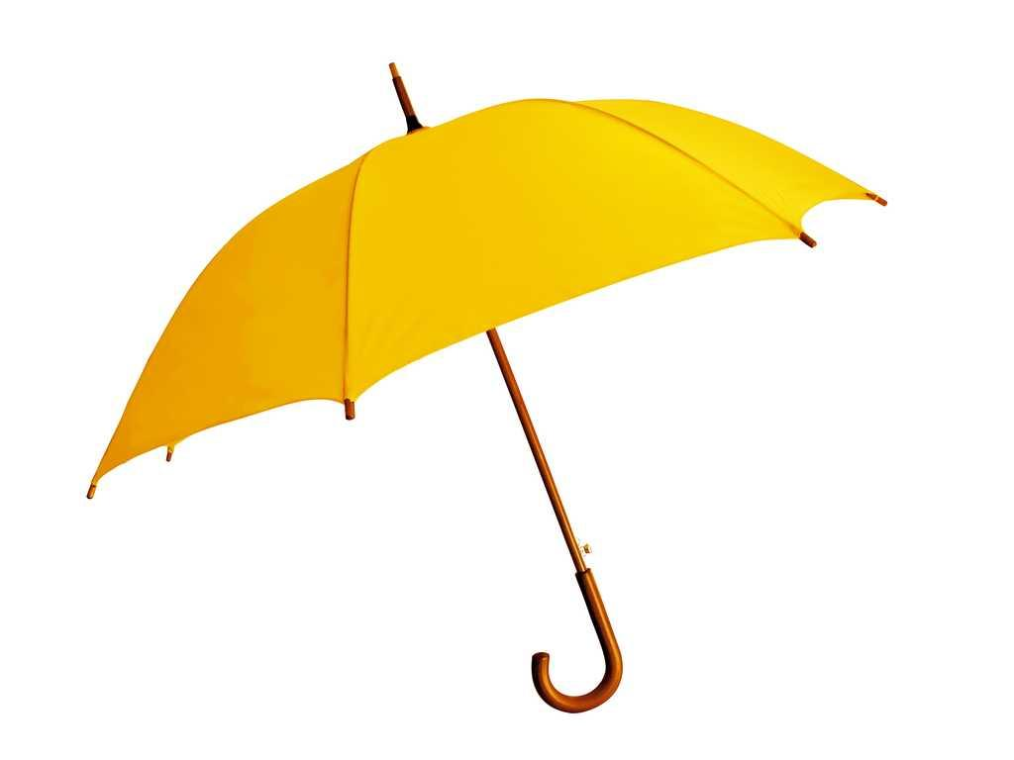 ●

● Soft

● Hard

● Flexible

● Rigid

● Absorbent

● Waterproof

12. What do we use these machines for? Write.
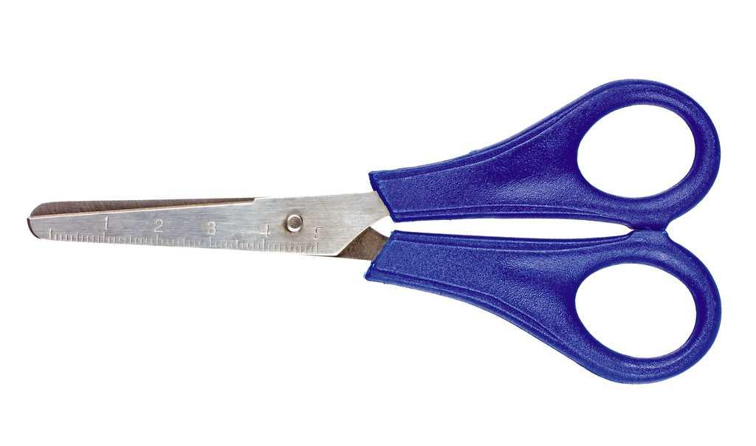

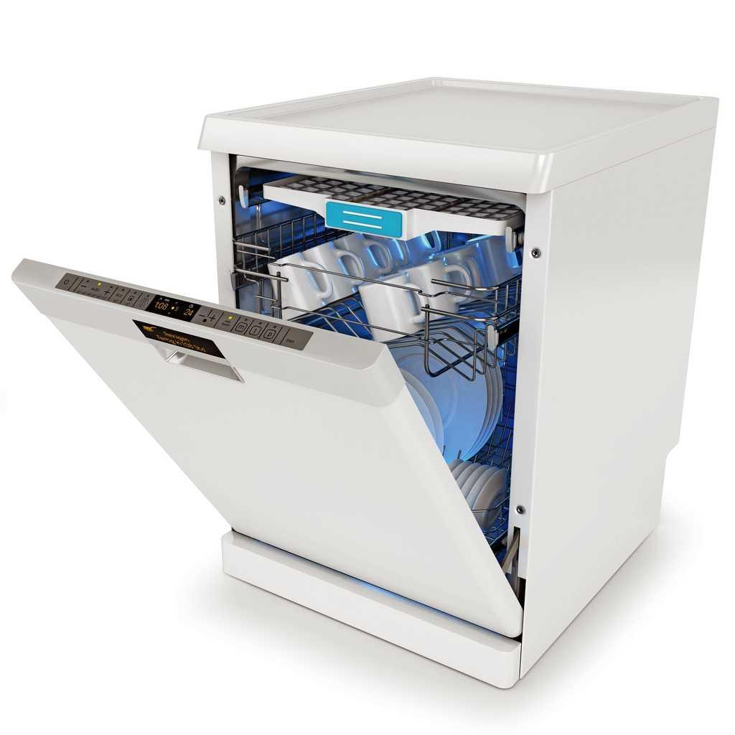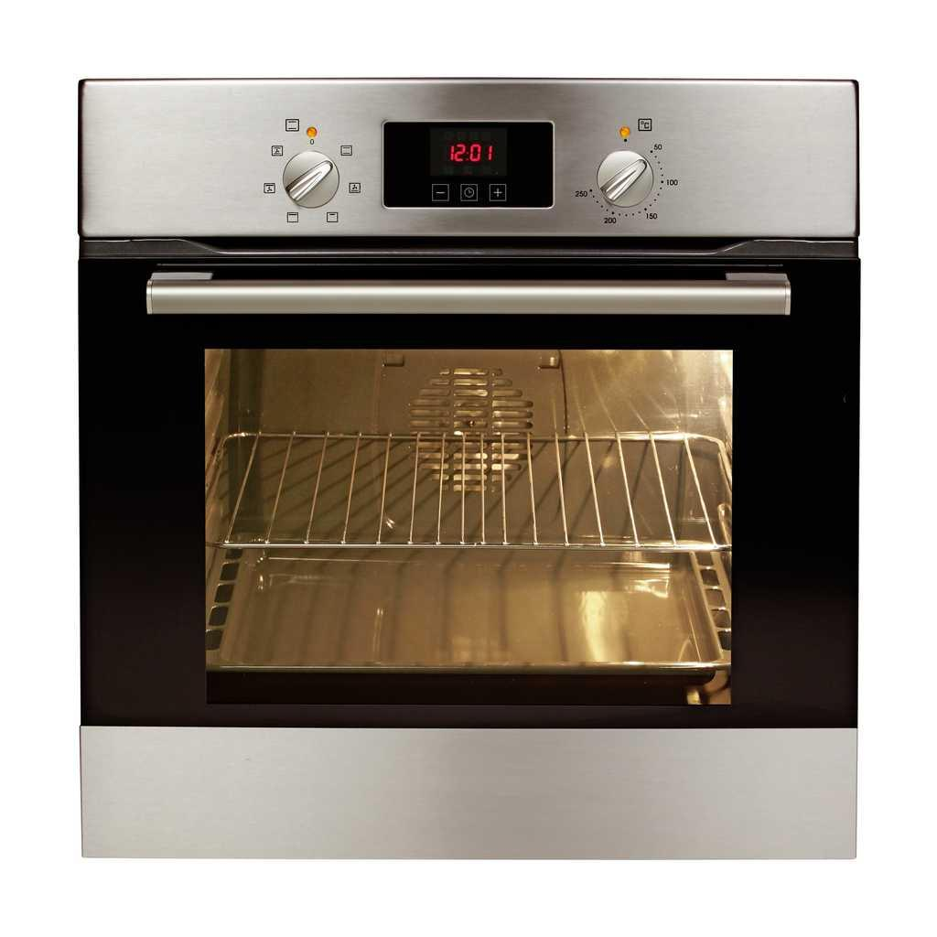

13. Draw an example of three types of inventions.

Transport Medicine Communication

