1. Complete these sentences.
● is everything around us that has mass and volume.
● is the space that an object occupies.
● is the amount of matter there is in an object.

2. Write True (T) or False (F).

● We measure mass in litres.

● We measure volume in grams or kilograms.

3. Label the picture with the words in the box.
pure substance, homogeneous mixture, heterogeneous mixture

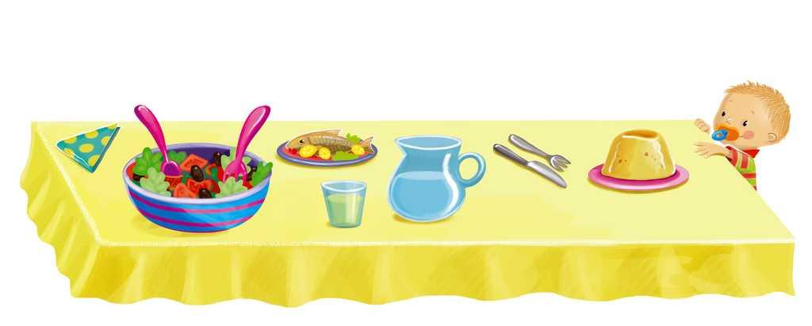

4. Which sentences are correct? Circle.
A. Solid matter has a definite shape. It occupies the same amount of space at all times.
B. A liquid occupies the same amount of space at all times.
C. A gas has a definite shape and volume.

5. Write the names of the physical changes below each picture.

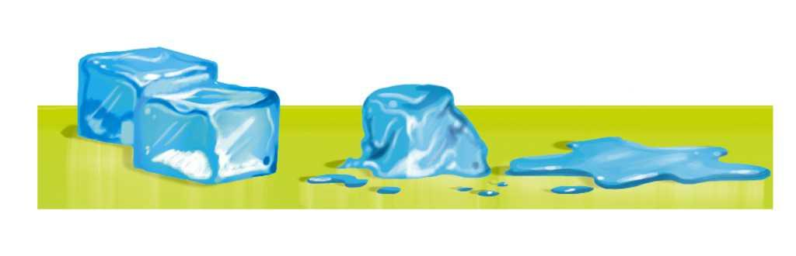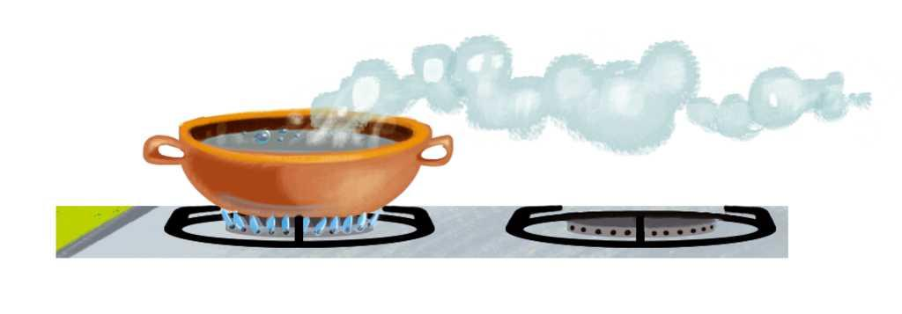

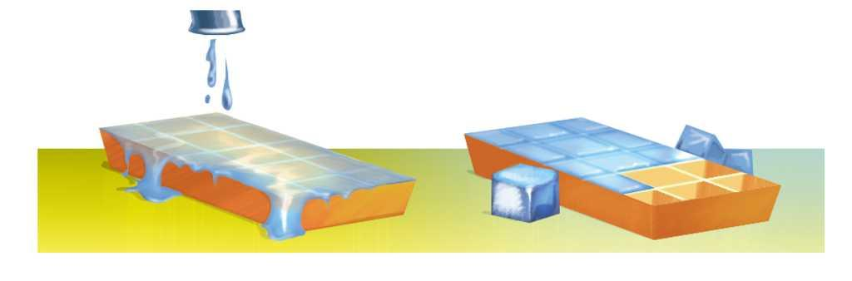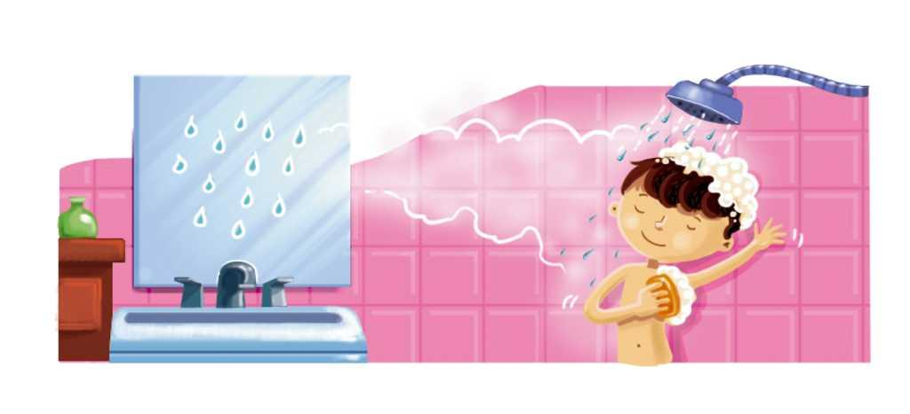

6. Complete these sentences.
● changes change the composition of matter and make new substances in the process.
● changes change the shape but the matter stays the same.

7. Write some examples of physical and chemical changes.

8. Write True (T) or False (F).
● A material of animal origin can come from under the ground.

● A material of plant origin can come from a tree.

● A material of mineral origin can come from a worm.

9. Which sentence is the best definition of artificial materials?
A. Materials that we find in nature.
B. Natural materials that we transform into other materials.
C. Materials of mineral origin that we transform into other materials.

10. Match the properties of materials to the definitions.

Conducts heat ●

Impermeable ●

Transparent ●

Elastic ●

Strong ●

Flexible ●

● They support heavy things.

● You can stretch them but they return to their original shape.

● You can see through them.

● Heat travels through them.

● Liquids stay inside them.

● You can fold them many times and they don’t break.

11. Complete the text with the correct materials.
If we want to build a house, we must use , because it is very hard and strong. For the windows, we use a transparent material like . For the walls and roof of the, house we use impermeable materials like bricks and .

12. Choose the material in the box that each sentence is describing.
polyester, cotton, wool and leather,
plastic and wood, rocks, steel, asphalt

● It is hard and strong and we use it for making machines and tools.
● They are natural materials and we use them for making clothes and shoes.

● It is impermeable and we use it for making roads.
● We use them for making tools that protect us from heat and electricity.

● They are hard and strong and we use them for building walls.
● It is an artificial material and we use it for making clothes.

13. What are the 3Rs and what do they mean?

14. Classify these machines in the table below.
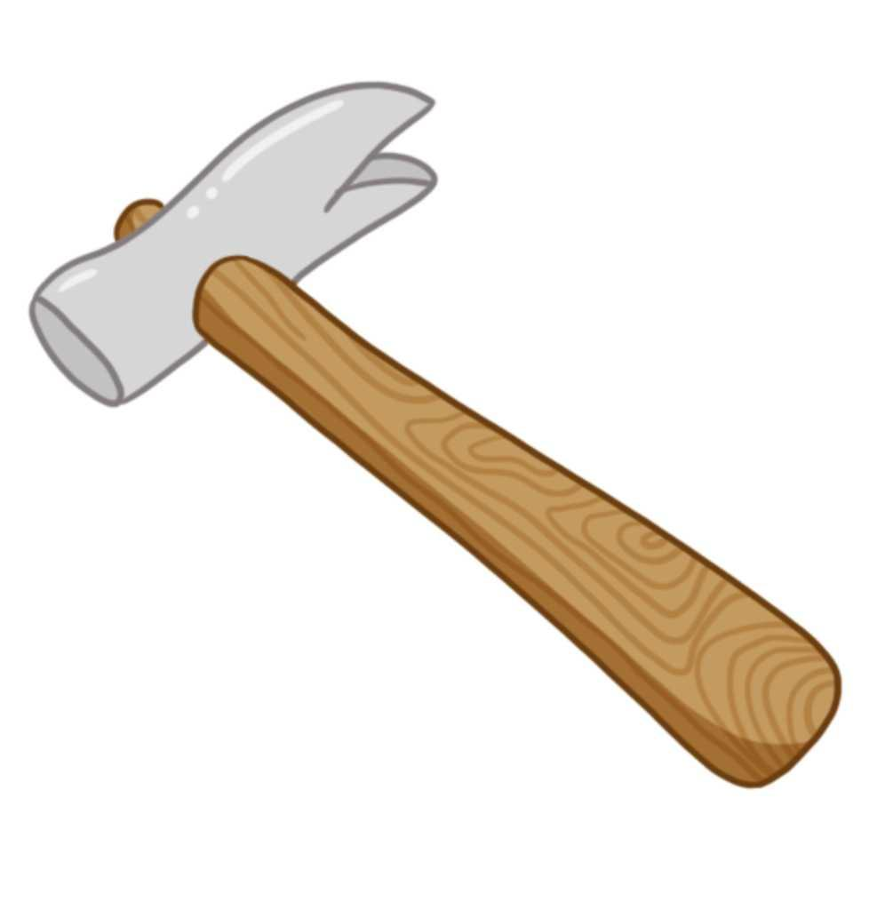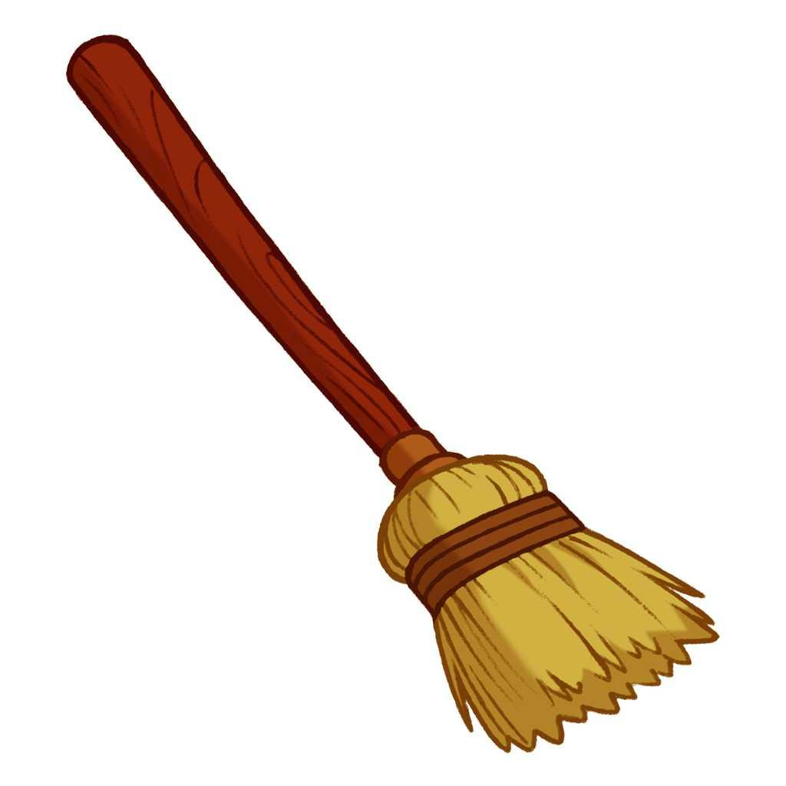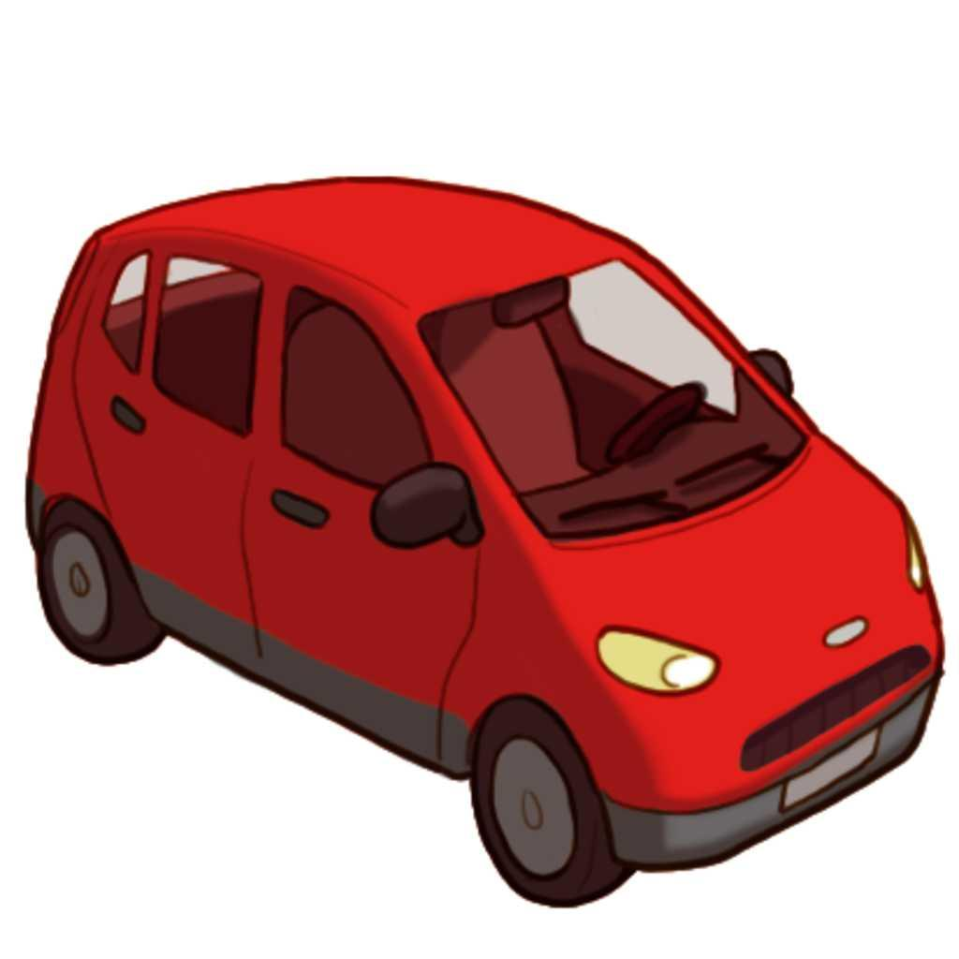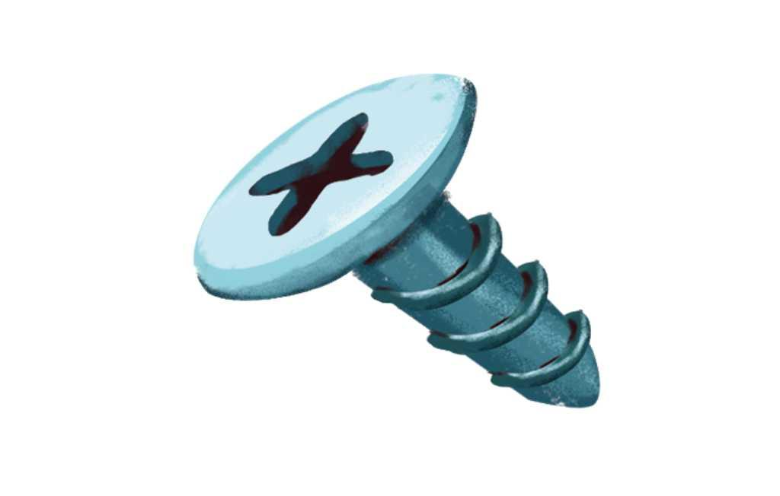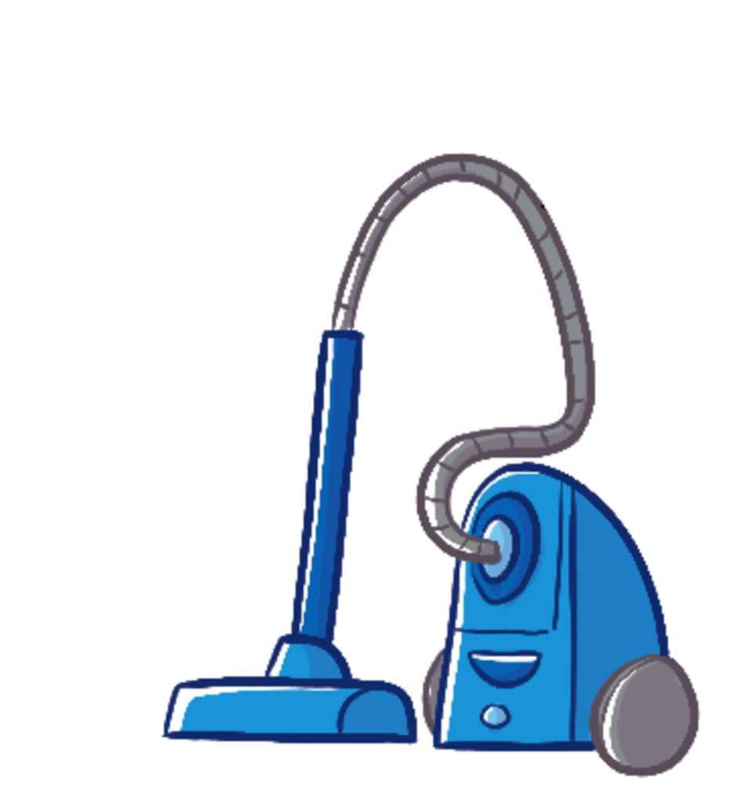

Simple machines | Complex machines

15. Match the type of energy with its definition.

Manual energy ●

Electrical energy ●

Heat ●

● Electricity creates this energy.

● Burning materials create this energy.

● Humans generate this energy.

16. Complete the text using the words in the box.
axle, pivot, rope, lever, pulley, simple, wheel

A machine is made from one or two components. The most common ones are:
- The . This is a long bar that moves up and down over a point we call a .
- The . This is a circular object that rotates around a central
.
- The . This has a wheel and a .

17. Write True (T) or False (F).
● Brakes are a set of axles that are joined to the handlebar.

● The handlebar is a lever that changes the direction of the bike.

● The wheels of a bike turn on a lever.
18. Match the machines to their uses.

Printing press ●

Steam engine ●

Radio ●

● Uses the energy from water vapour to move machines.

● Allows us to reproduce books.

● Tells us what is happening in the world.

19. Machines are constantly changing. Circle the incorrect reason for changes to machines.
A. The discovery of new materials, like plastic.
B. The discovery of new energy sources, like electricity.
C. The discovery of new means of transport.

