1. What are the elements most structures have? Circle the correct answer.
A. Axle, crank and cogs.
B. Girders, pillars and load.
C. Force, pivot and load.

2. Label the the pictures.
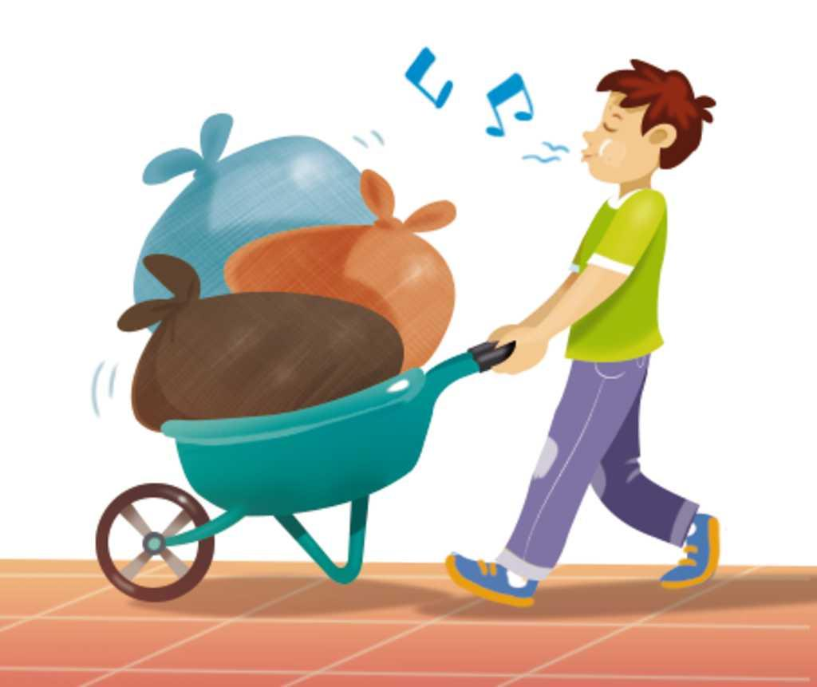

3. Complete these sentences.
● A can help us lift objects more easily.
● An lets us move objects using less force.
● We make a if we wrap an inclined plane around a cylinder.
● We get a if we join two inclined planes.

4. Write True (T) or False (F).

● The rectangle is a very strong shape.

● A ramp is an example of an inclined plane.

● A bicycle is a complex machine.

5. Circle the correct sentence.
A. First steam trains were invented, and then engineers developed the diesel locomotive.
B. Energy from water mills and windmills is a non-renewable energy source.
C. Trains are a means of communication.

6. Complete the sentences with the words in the box.
clothing, accept, instructions, old, check, addictive

● When we throw away machines, we waste resources and pollute the environment.
● It is important to always follow and use machines properly.
● Social networks and playing online games can be .
● Sometimes we must use protective to use machines safely.
● We must that the machines we use are working correctly.
● SMART means: safe, meet, , real and tell.

7. Match the words to the definitions.

Structure ●
Lever ●
Pulley ●
Inclined plane ●

● It has a rigid bar. It transmits a force which makes it easier to lift a load.
● It lets us move objects using less force.
● It changes the direction of the force, but the force and the load are the same.
● A group of elements that can support weight or a load.

8. Write True (T) or False (F).
● The first steam trains burnt diesel to heat water.

● We use the power of water to produce energy with the windmill.
● Typewriters, desktop computers and laptops are inventions that have made communication easier.

9. Label the pictures.

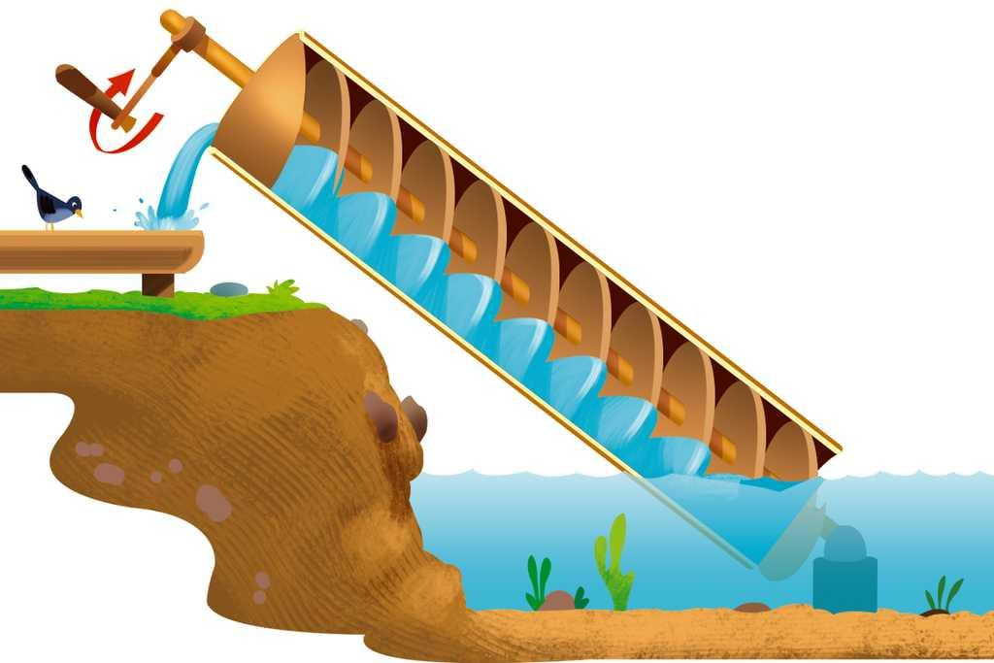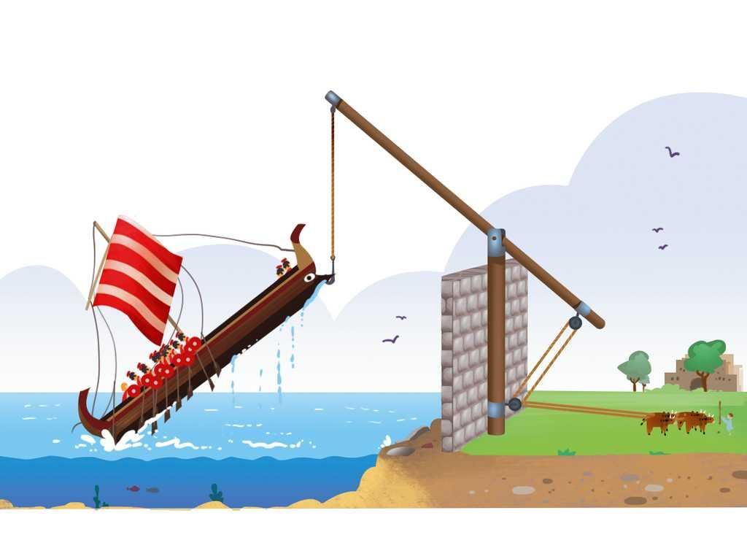
The of Archimedes The of Archimedes

10. Which of these sentences is incorrect? Circle.
A. Hundreds of years ago, people used water mills and windmills to make flour from wheat.
B. Nowadays, we use water mills and windmills to make electricity.
C. Both sentences are incorrect.

11. Classify these machines as simple or complex in the table below.
catapult, ramp, wedge, bicycle

Simple machines | Complex machines

12. Match the complex machines with their picture.

Crank ●
Gear ●
Cogs and chain ●
Rack and cog ●

● 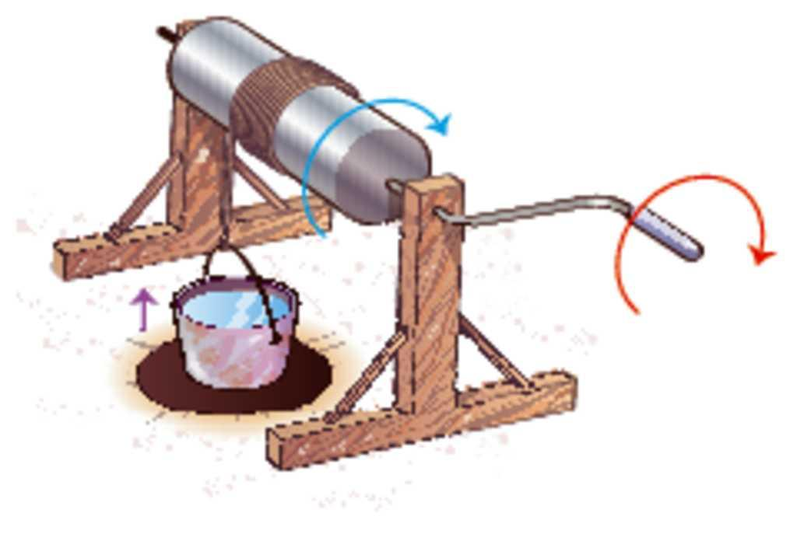
● 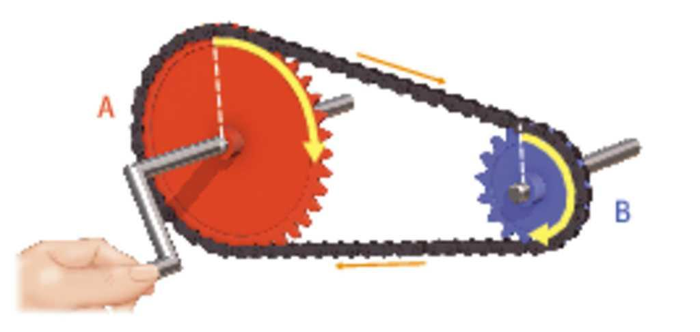
● 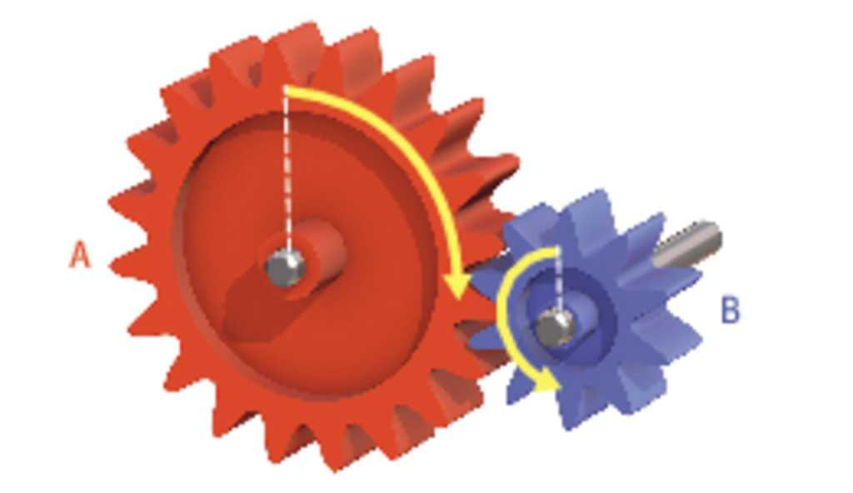
● 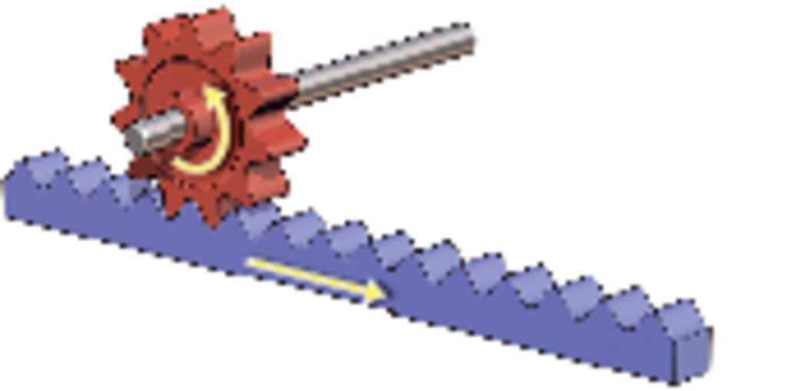

13. Write a brief description about the use of the screw of Archimedes.

14. Circle the correct sentence.
A. Class 1 levers have the pivot at one end.
B. Class 2 levers have the pivot in the middle.
C. Class 3 levers have the pivot at one end.

