1. Match each type of energy with its definition.

Mechanical energy ●

Light energy ●

Nuclear energy ●

Heat energy ●

Chemical energy ●

Electrical energy ●

● It is the energy that is emitted by lightning and bodies like the Sun.

● It is the energy that is emitted by bodies like the Sun, fire or the lava of a volcano.

● It is the energy that is stored in substances like the food we eat and fuels like oil and coal.

● It is the energy that is associated with the presence and motion of electrical charges.

● It is the energy that is associated with the motion and position of an object.

● It is the energy in the nucleus of an atom.

2. Write True (T) or False (F).
● Energy has mass.

● Energy occupies no space.

● Electrical energy is transformed into heat energy in a fan.

● Energy can transfer from one body to another.

● Electrical energy can be transported through cables.

3. Explain the difference between renewable and non-renewable energy.

4. Classify the energy sources in the table below.
biomass, petrol, geothermal energy, uranium, hydroelectric energy, coal, tidal energy, gas

Renewable | Non-Renewable

5. Complete the text about the negative consequences of energy production. Use the words in the box.
warming, spills, erosion, quarries, carbon dioxide, waste, mines

The burning of fossil fuels releases into the atmosphere and causes global . Oil from tankers and industrial contaminate the sea and kill aquatic organisms. Taking rocks from and minerals from contaminates the land and causes soil
.

6. Name four things we can do to create a sustainable future for our planet.

7. Write the names of the effects of changes in temperature on matter.
● A change in volume that takes place when air cools down.
● A change in state that takes place when air cools down.
● A change in volume that takes place when air is heated.
● A change in state that takes place when a solid is heated.

8. Write True (T) or False (F).
● Heat always travels from the warmer body to the colder one.

● Thermal insulators allow heat to travel quickly.
● Thermal conductors do not let heat pass through them easily.

9. Match this words with the definition.

Translucent material ●

Reflection ●

Transparent material ●

Refraction ●

Opaque material ●

● The change of direction that occurs when light hits an object.

● The change of direction that occurs when light passes from one medium to another.

● Does not allow light to pass through it.

● Allows light to pass through it but disperses the light.

● Allows light to pass through it without dispersing.

10. Name the type of lens in each picture.
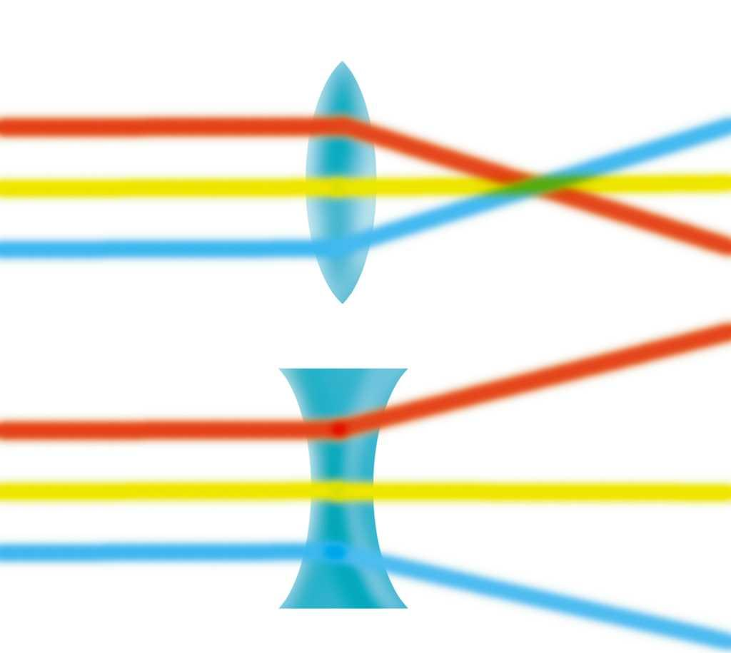
lens

lens

11. Read the sentences about sound. Write True (T) or False (F).

- A violin has a high pitch and a double bass has a low pitch.

- Sound travels more slowly through the ground than the air.

- Sound is produced by the vibration of bodies.

- Sound cannot travel through water.

12. When you pull off a polyester jumper, your hair sticks up. Explain what makes this happen.

13. Explain what happens to an electrical device if you put an insulator in a circuit.

14. Label the picture.
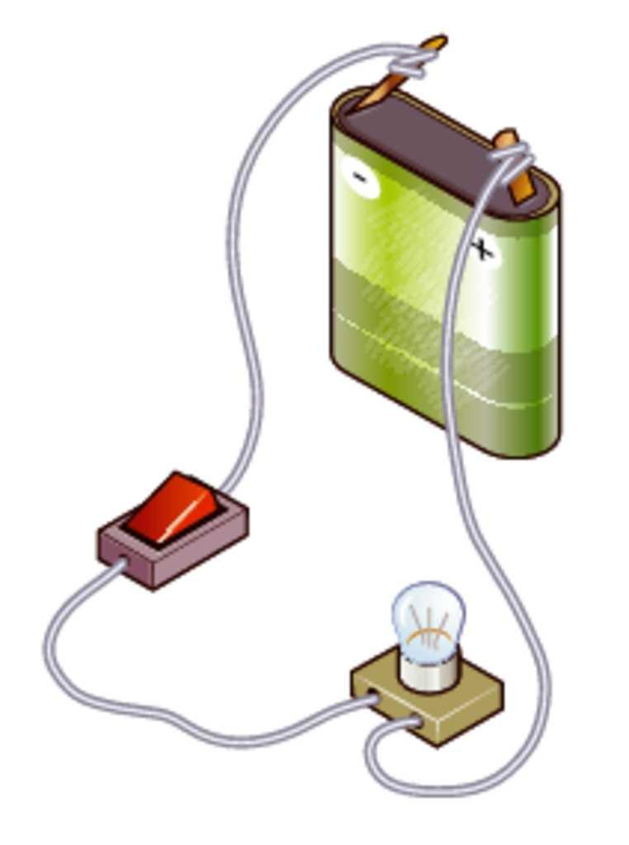

15. Match each word with its definition.

Heat ●

Light ●

Sound ●

● It is a form of energy that travels in straight line at great speed.

● It is the transfer of energy between two bodies that are at different temperatures.

●It is a form of energy that is produced by the vibration of bodies

