1. Write True (T) or False (F). Then, correct the false sentences.
- A snake has got fur.
- An elephant has got scales.
- A duck has got feathers.
- A pig has got skin.

2. Read and complete. Use the words in the box.
abdomen, wings, antennae, eyes, legs

A fly is a small black insect. It hasn’t got a backbone. It has got two ………………………………………………… on its head. Its body has an ………………………………………………… and a thorax. It has ………………………………………………… for flying. It has six ………………………………………………… and two ………………………………………………….

3. Read and circle the correct words.
- An oviparous / viviparous animal is born from its mother’s womb
- An oviparous / viviparous animal is born from an egg.
4. Label the picture. Use the words in the box.
body, head, tail

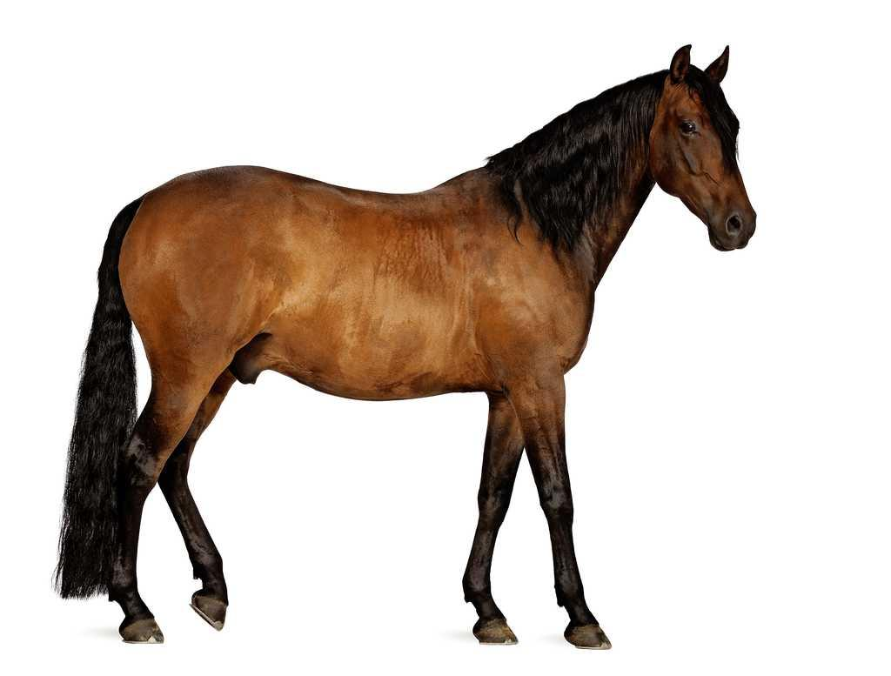

5. Read and circle the correct words.
- A vertebrate / invertebrate animal has got a backbone.
- A vertebrate / invertebrate animal has not got a backbone.

6. What do these animals eat? Match the columns.

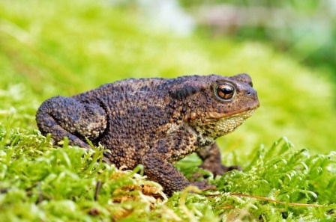 ●
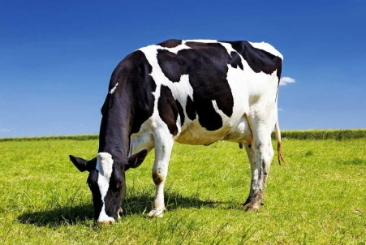 ●
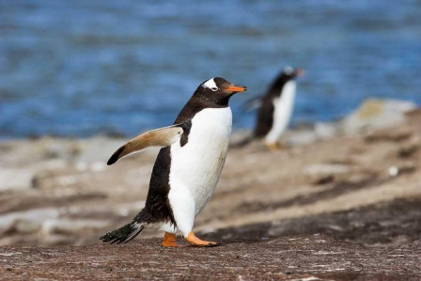 ●

●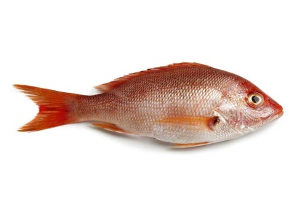
●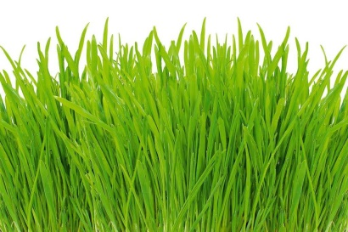
● 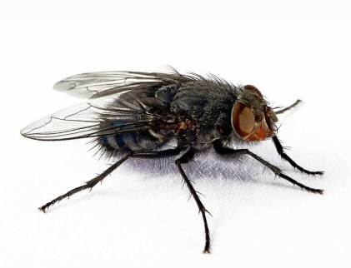

7. Draw an herbivore in teh box.

8. Circle the viviparous animals in blue. Circle the oviparous animals in green.
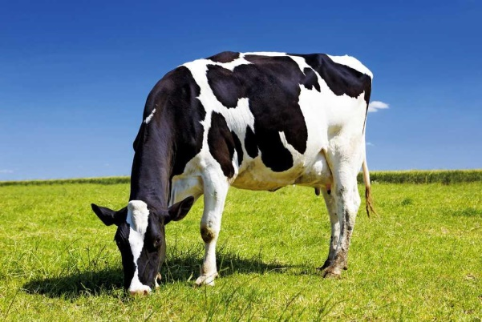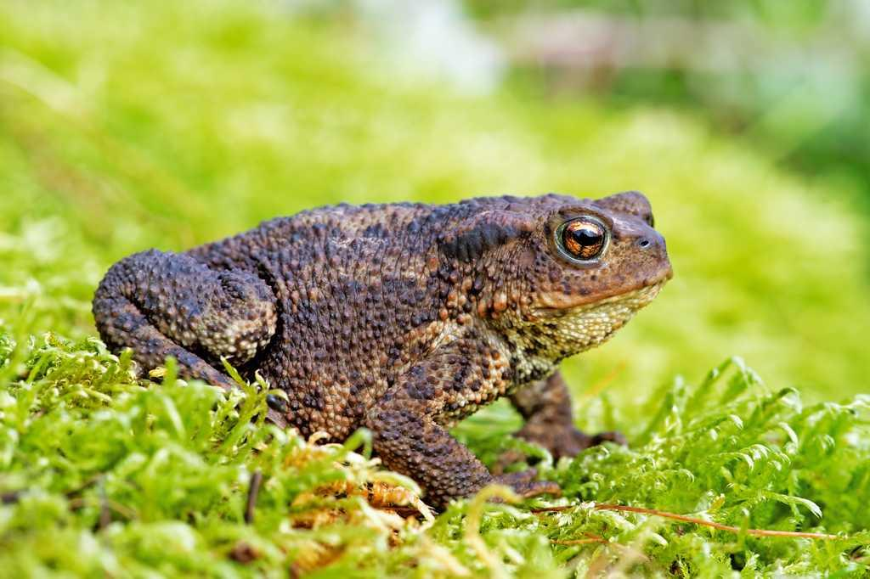
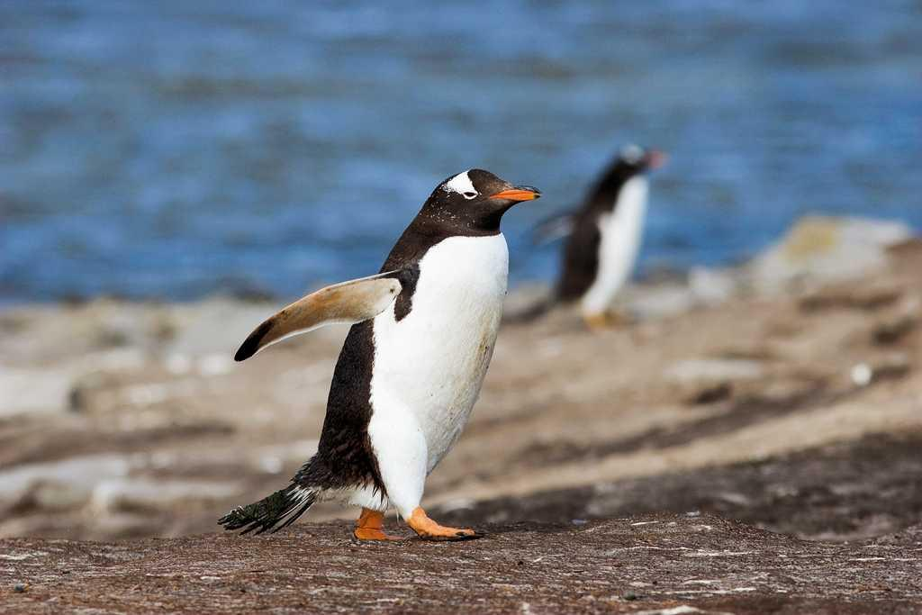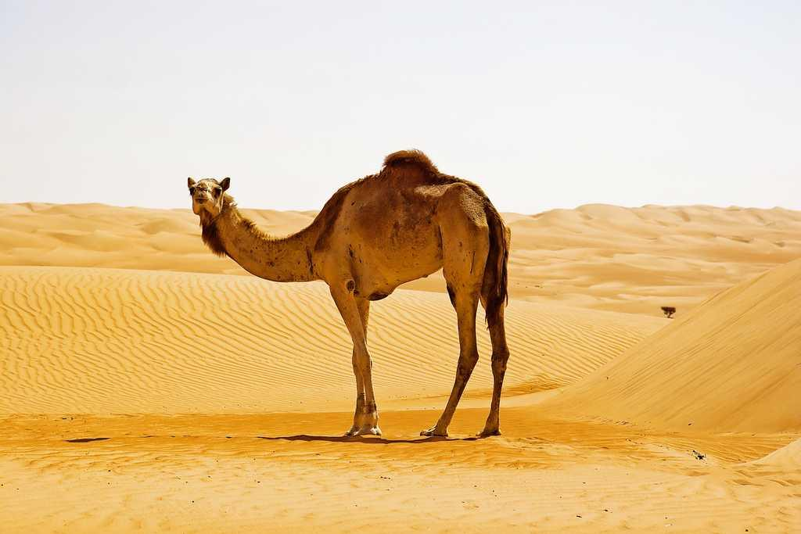

9. Read and circle the correct word.
This animal eats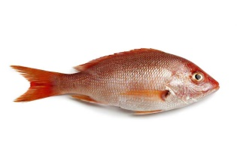 and 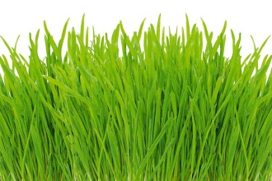 . It is a/an … .
- carnivores
- omnivores
- herbivores

10. Circle 3 words for animals.
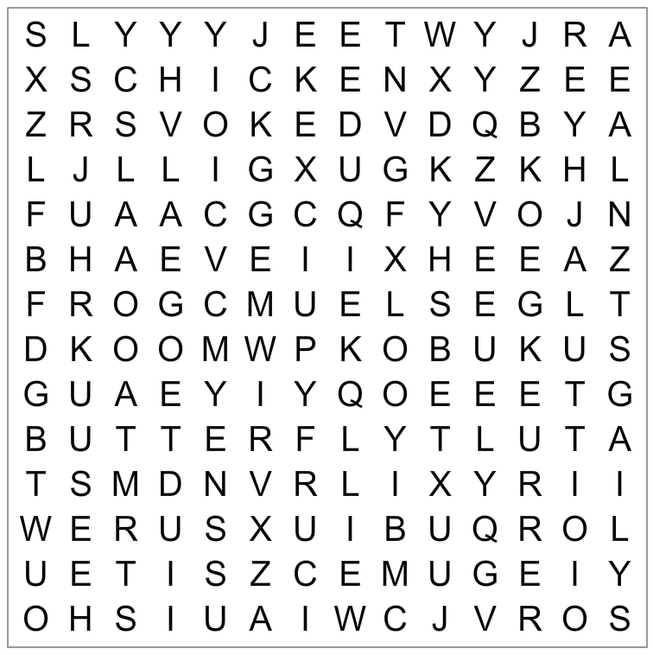

11. Write True (T) or False (F). Then, correct the false sentences.
- A giraffe swims.
- A bat flies.
- A fish walks.

12. Where do these animals live? Label the pictures. Use the words in the box.
savannah, hot desert, forest, cold desert

…………………………………………………
…………………………………………………
…………………………………………………
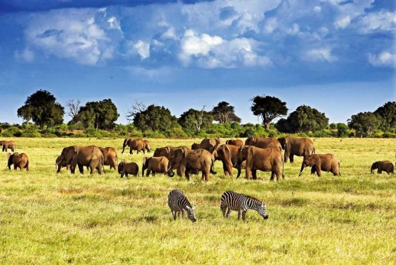 …………………………………………………

13. Read and circle the correct words.
- Rabbits move on land / in the air.
- Parrots move on land / in the air.
- Whales move in water / in the air.

14. Read and draw.
This is a vertebrate animal. It has got feathers. It moves in the air.. It is a carnivore.

