1. Label the pictures. Use the words in the box.
mountain, coastal, urban, rural

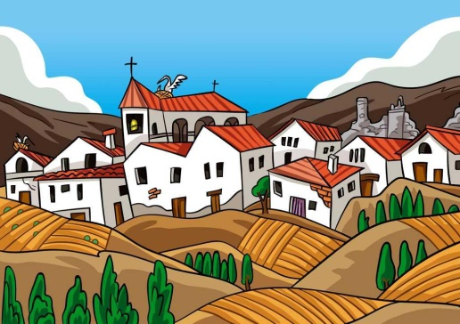 ………………………………………………
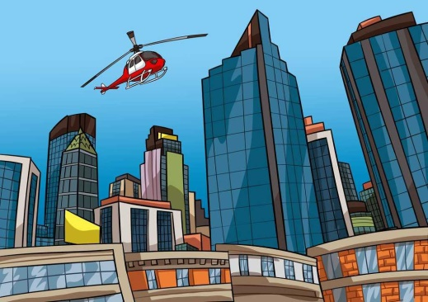 ………………………………………………
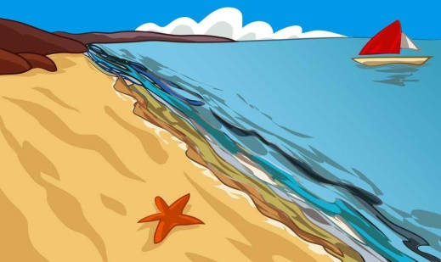 ………………………………………………
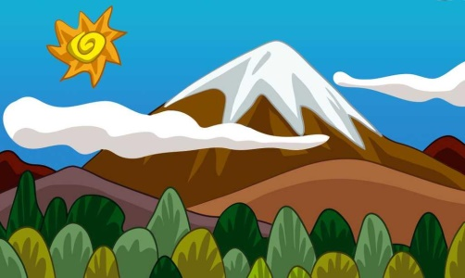 ………………………………………………

2. Circle the artificial landscapes in blue. Circle the natural landscapes in green.
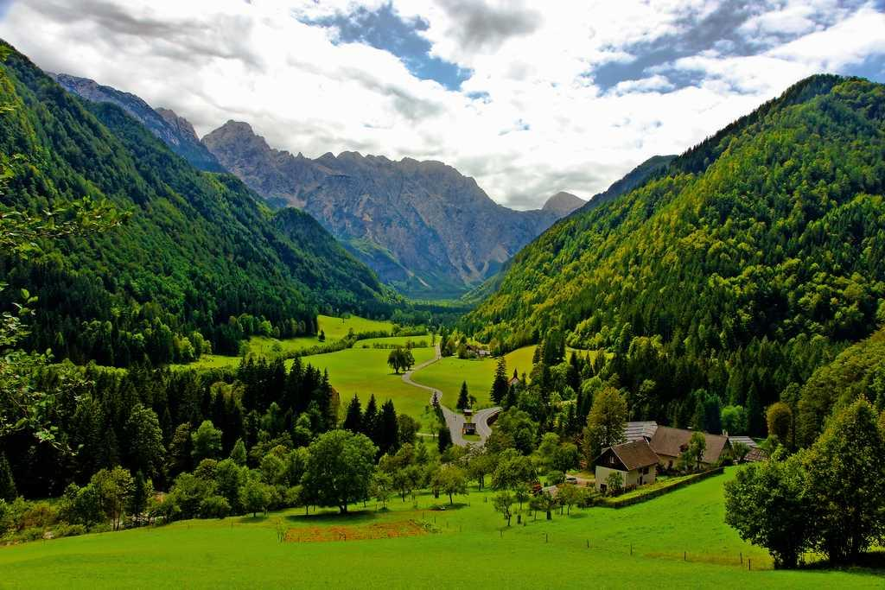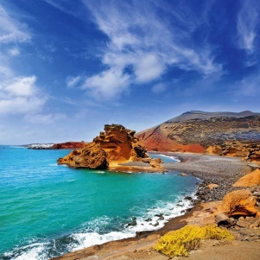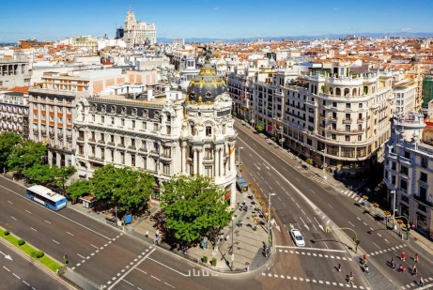

3. Circle the lake.
- 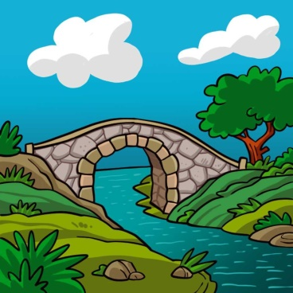

- 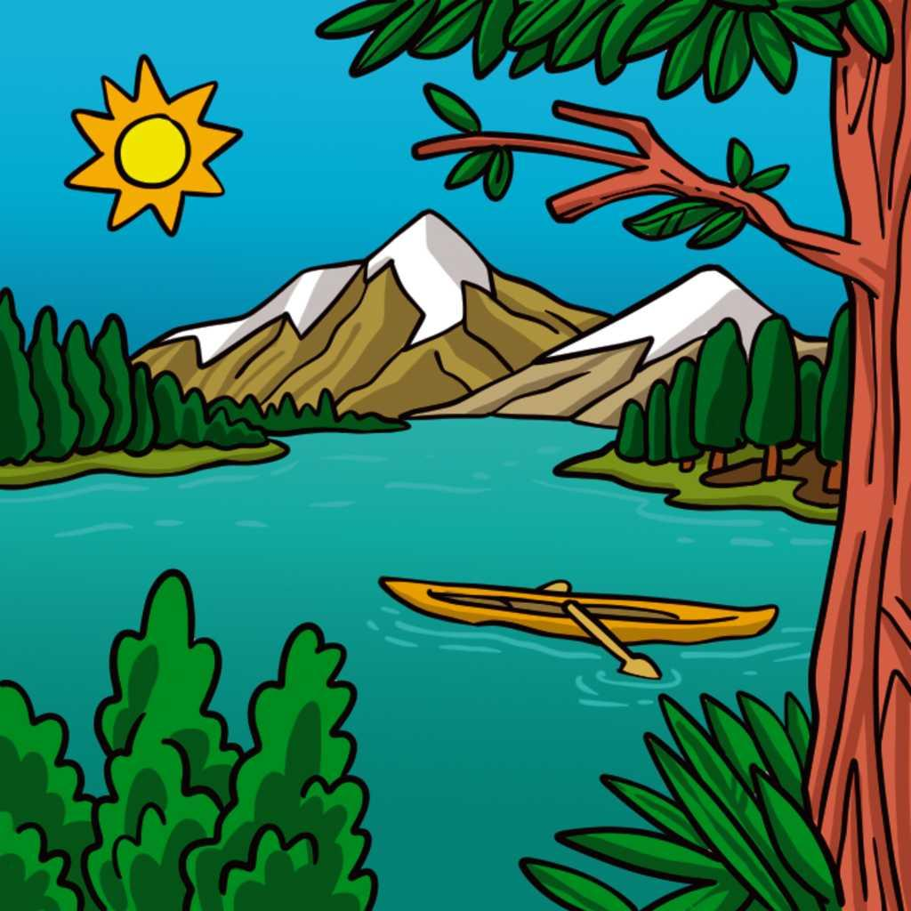

- 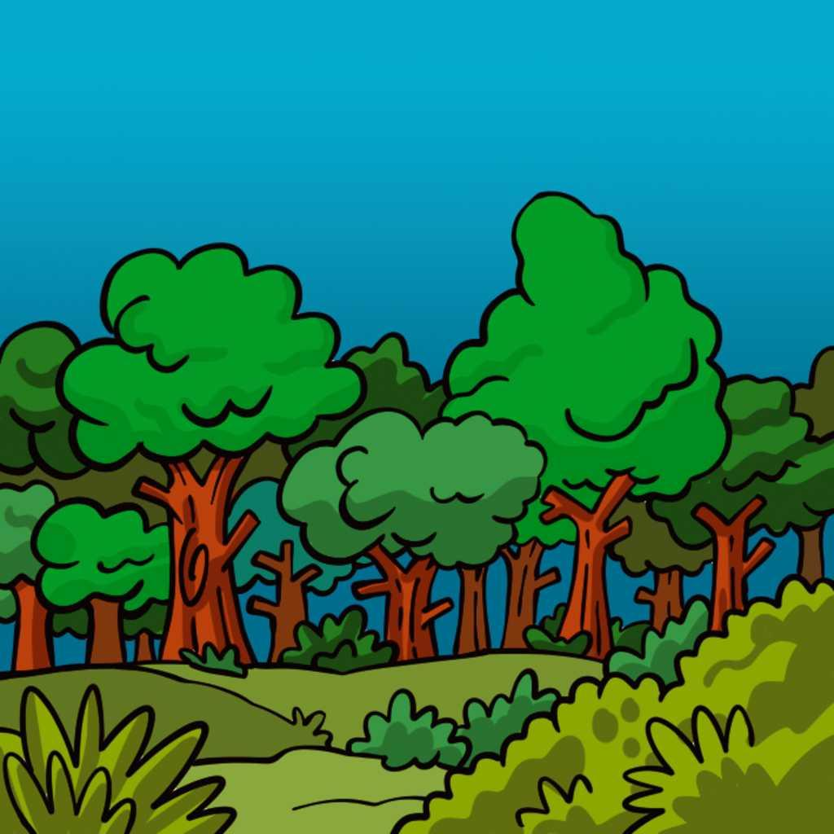

4. Read and match.

Lighthouse ●

Tunnel ●

Road ●

● 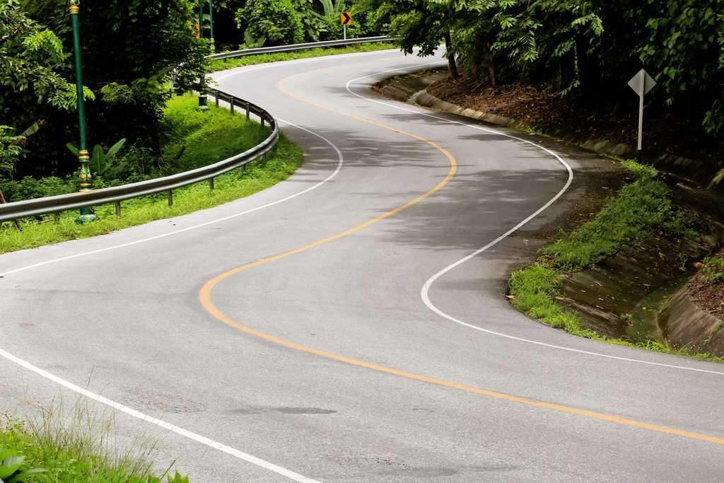
● 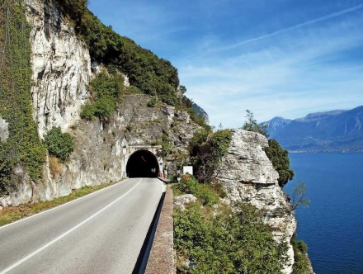
● 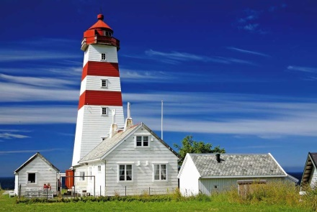

5. Write True (T) or False (F). Then, correct the false sentences.
- Gold makes cathedrals.
- Clay makes jewellery.
- Diamonds make rings.

6. Circle three words for minerals and one for a rock.
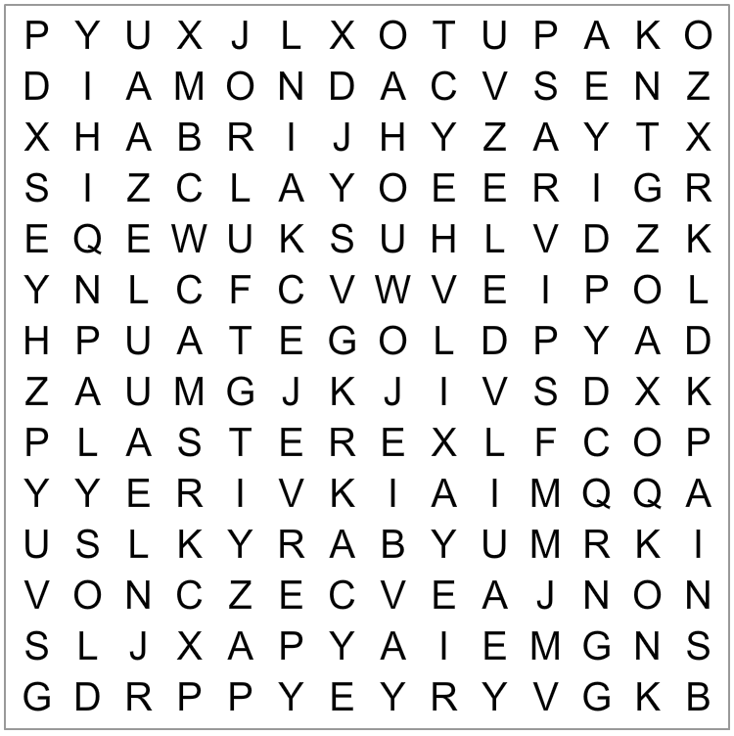

7. How can we take care of the environment? Circle the correct words.
- Don’t recycle / Recycle rubbish.
- Ride a bike / Use a car.
- Don’t drop / Drop rubbish in the street.

8. Match the pictures with the bins.
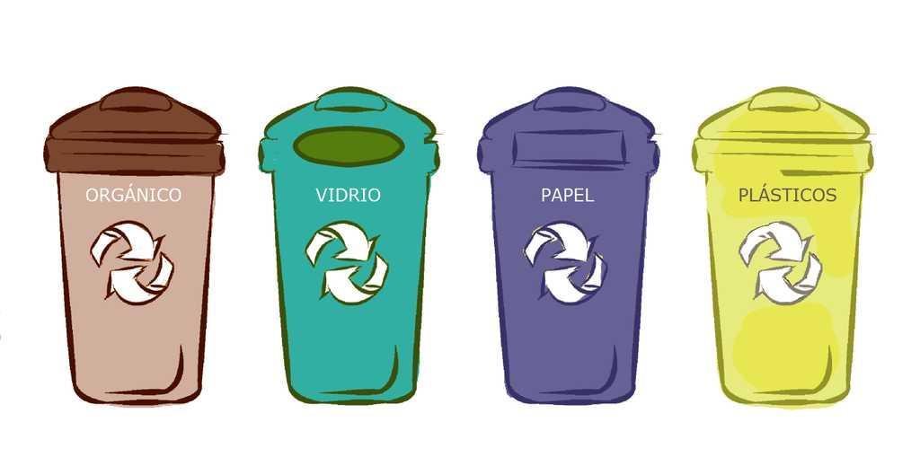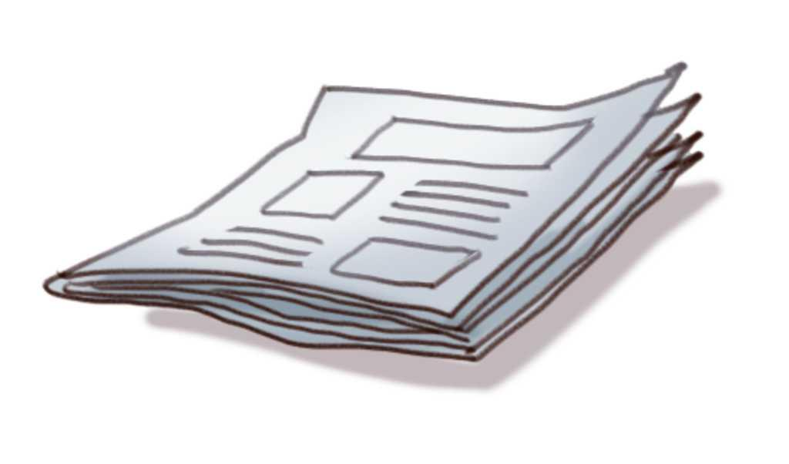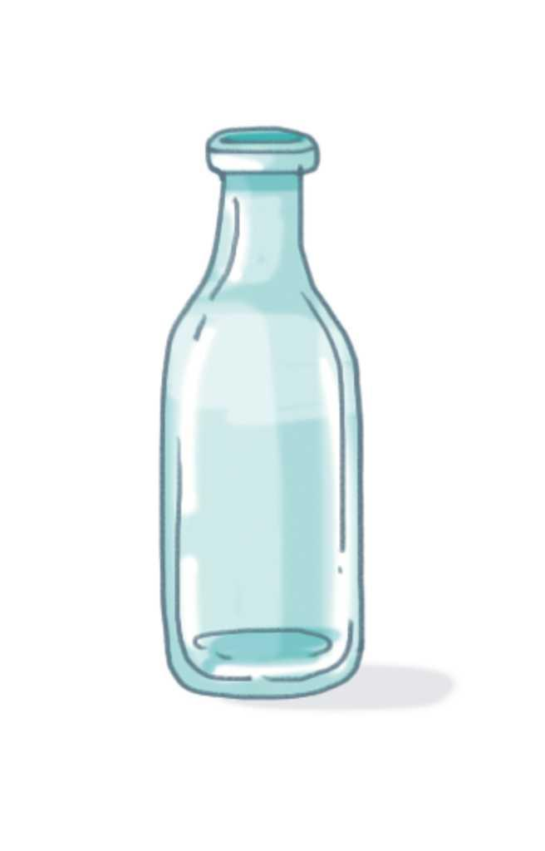

9. Are they polluted or clean?
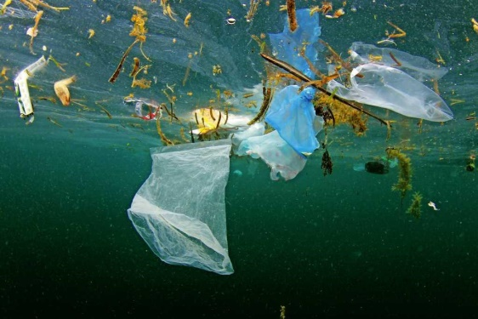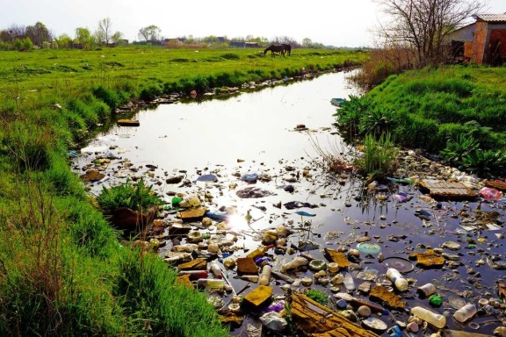

………………………………………………

10. Who is saving water? Circle.
- 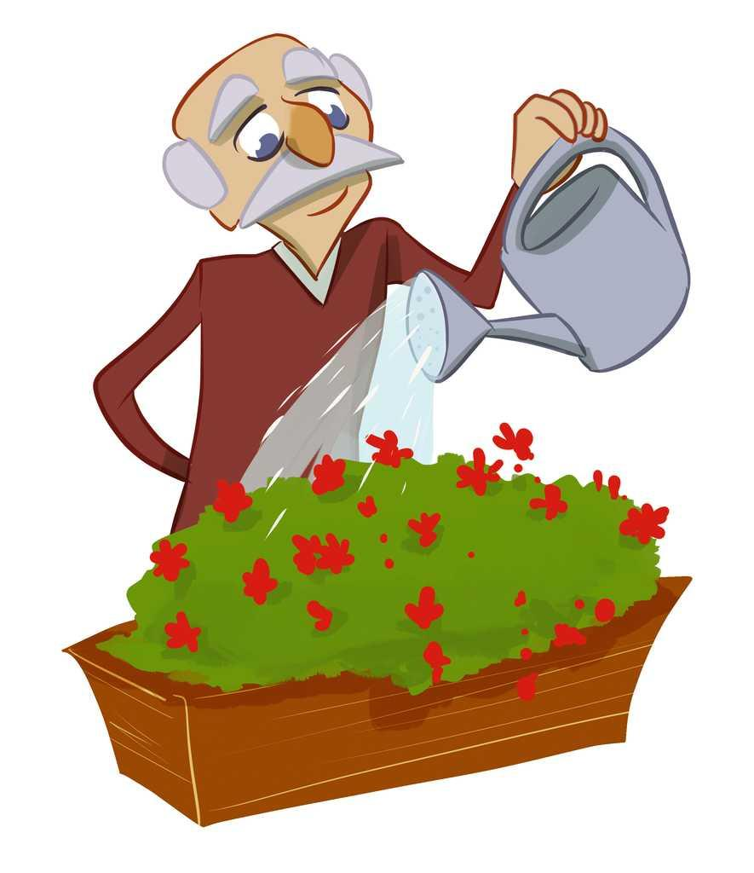
- 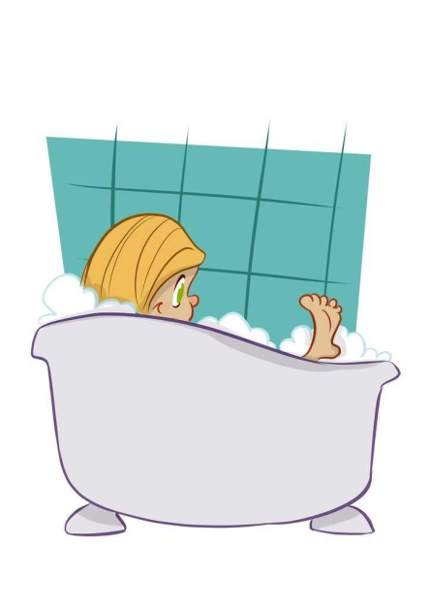
- 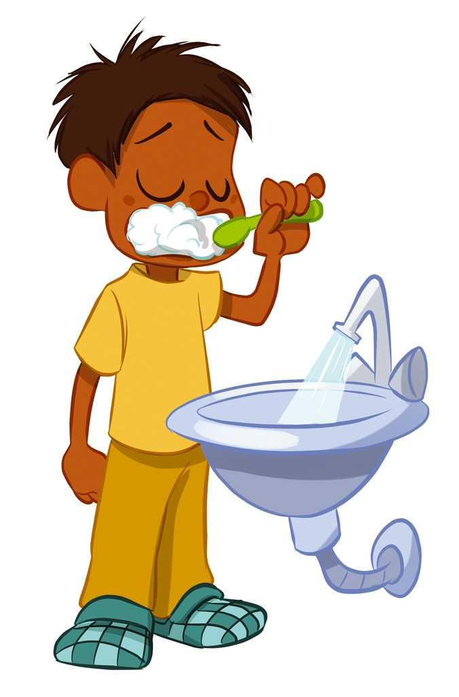

11. Read and complete. Use the words in the box.
snowy, rainy, sunny

- In winter, it can be ……………………………………………….
- In summer, it is ……………………………………………….
- In spring, it can be ……………………………………………….

12. Label the pictures. Use the words from the box.
snowy, cloudy, rainy, stormy

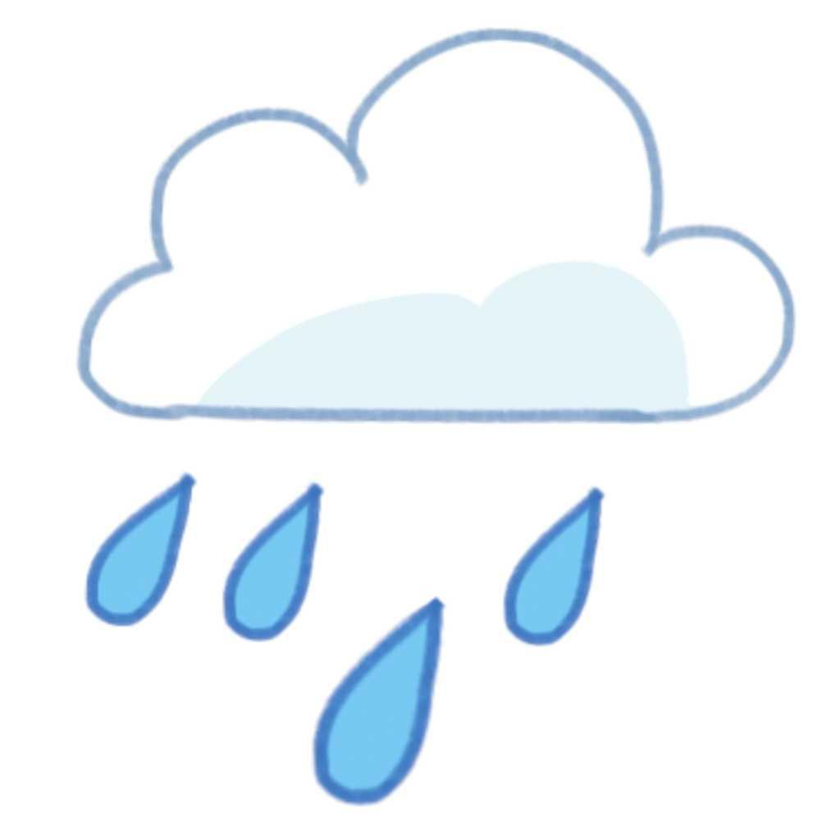 ……………………… …………………………… 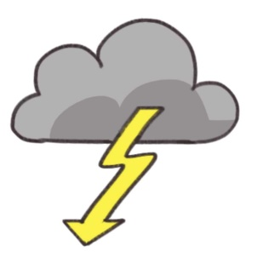 ………………………… ………………………………

13. Read the sentences and draw the pictures.
- The lake is polluted.

- It is a snowy day.

