1. Read. Circle the correct option.
● The future / past is the period of time before this moment.
● The future / present is the period of time after this moment.
● The past / present is this moment now.

2. How do we measure time? Circle.
A. 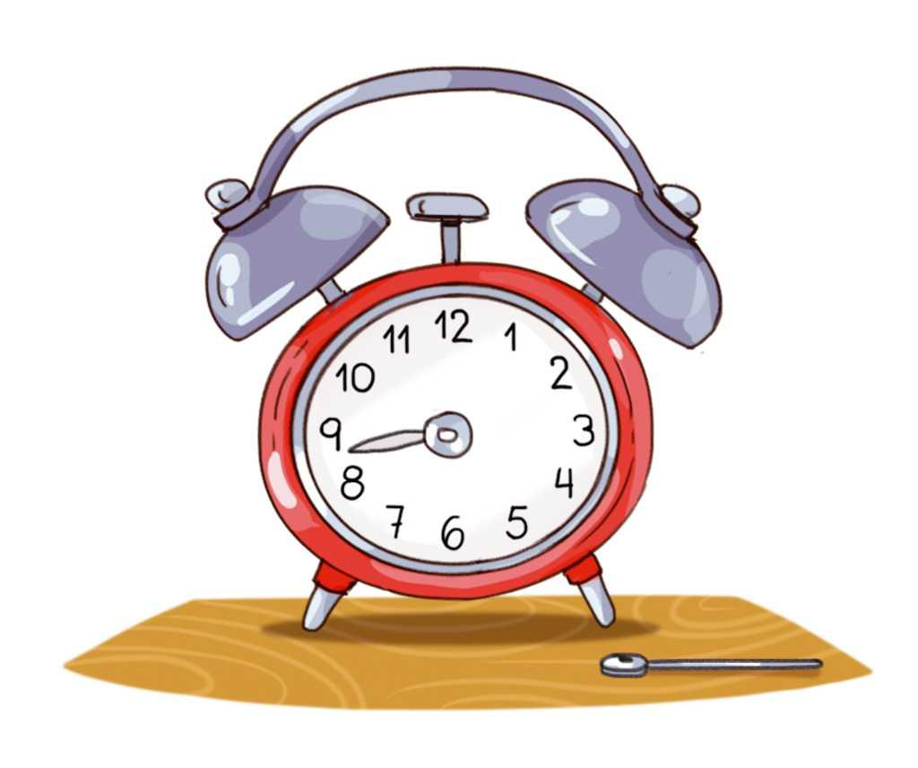
B. 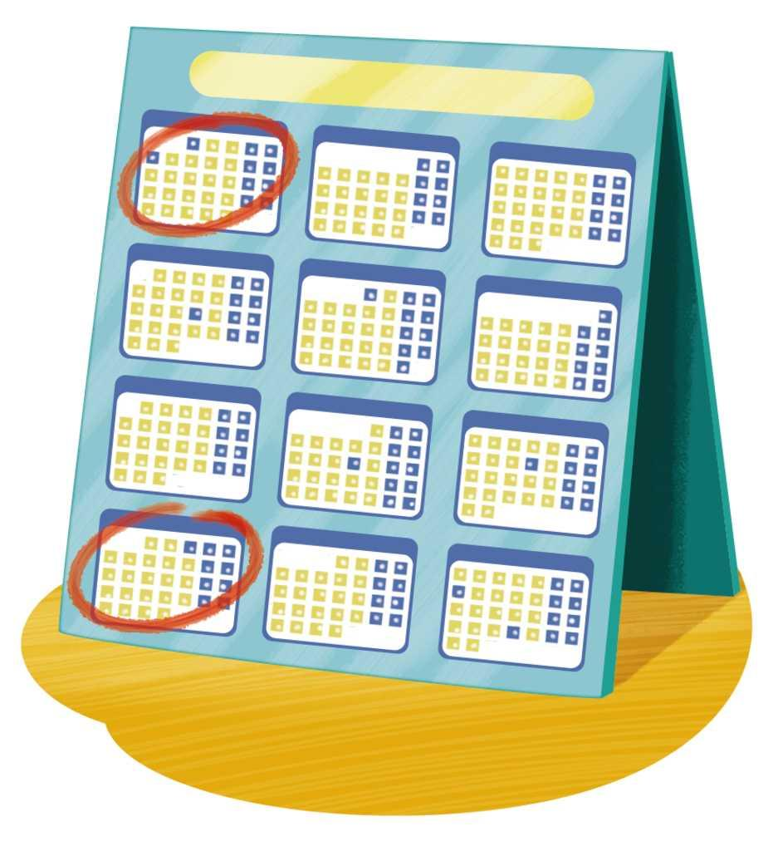
C. 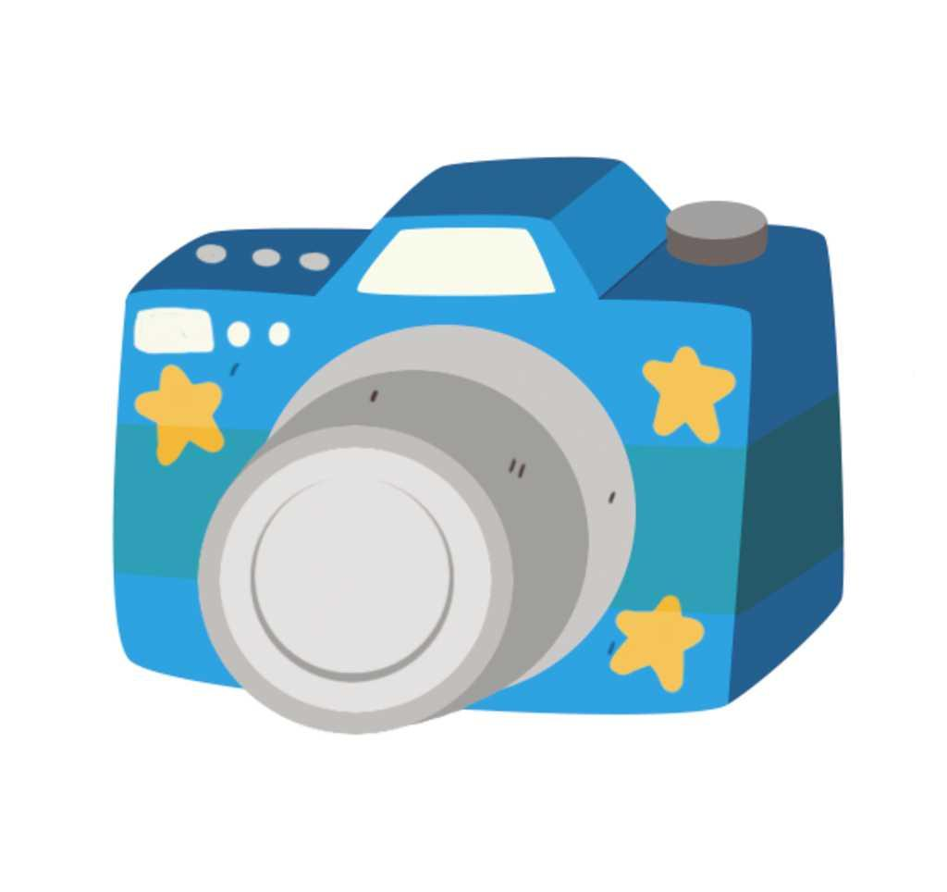

3. Write True (T) or False (F).

● History is the study of human beings from the present.

● Historians investigate the lives of people from the past.

● A century is 100 years.

4. Look at the pictures. Label them with the periods of history.
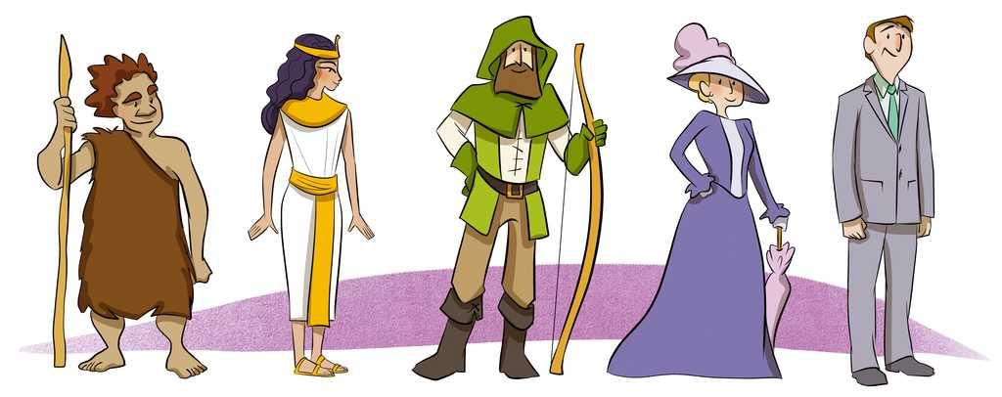

5. Read and complete. Use the words in the box.
primary source, secondary source, findings, artefacts

● : historians get information from these objects.
● : this is direct evidence or testimony from the past.
● : this is the interpretation of a primary source.
● : these are the results of a study.

6. What can you see in the pictures? Classify the objects in the table below.

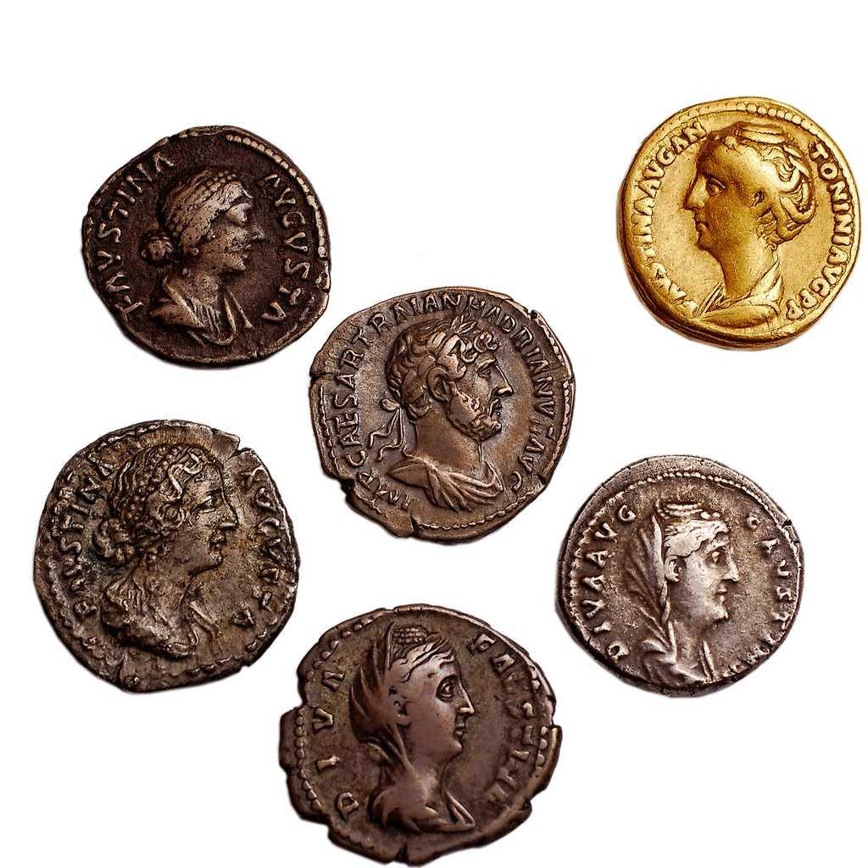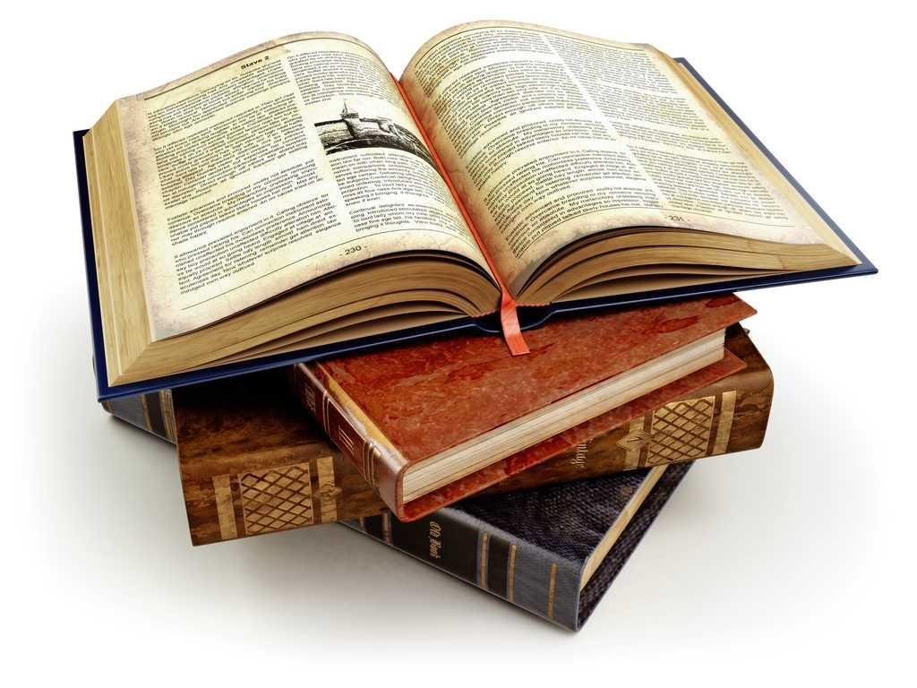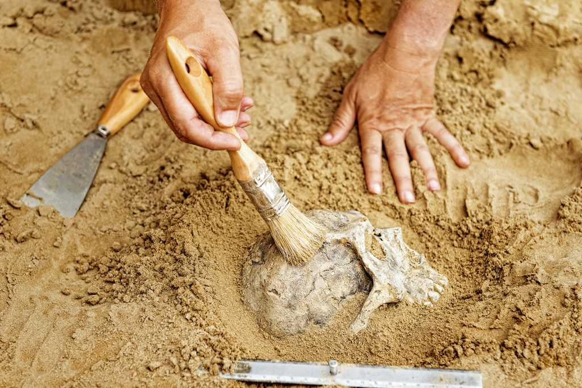
Primary source | Secondary source

7. Read and match.

Historical character ●

Historical event ●

Legend ●

Myth ●

● An important happening in the past.

● A traditional story about a historical event.

● A traditional story about heroes and gods.

● An important person in human history.

8. Write True (T) or False (F).

● Discoverers design and make new processes or things.

● Christopher Columbus and Alexander Fleming are two discoverers.

● Inventors find, explore or observe something for the first time.

● Alexander Graham Bell and Hedy Lamarr are two inventors.

9. Describe an invention you like.

10. Read and complete. Use the words in the box.
food, history, museums, cultural heritage, sculptures

Important things and ideas in societies pass to future generations. We call this our . Examples of our artistic cultural heritage are
, songs, dances and paintings. Monuments, traditions, costumes and are examples of cultural heritage too.
protect and preserve our cultural heritage. We can learn about our there.

11. In a museum, which actions do not preserve our cultural heritage?
A. Taking photos with a flash.
B. Drawing on the sculptures.
C. Touching the paintings.
D. Listening to the museum guide.
E. Looking at the exhibits from behind the barrier.

