1. Match the columns.

Past ●

Present ●

Future ●
● These are things that happen later.

● This is what is happening now.

● This is what happened before.

2. Classify these units of measurement in the table below.
hour, day, month, minute, second

Clock | Calendar

3. Read and answer the questions.
● How many years are there in 1 decade?
● How many years are there in 1 millennium?
● How many years are there in 1 century?

4. Read and complete the text with the words in the box.
History, hominids, Prehistory, the Modern Age, Ancient History

began with the first . They were the first human ancestors. It ended with the invention of writing.
began with the invention of writing. It consists of four ages:
, the Middle Ages, and the Contemporary Age.

5. Write True (T) or False (F).

● Contemporary Age: transport and communication are very fast.

● Modern Age: commerce developed and cities appeared.

● Middle Ages: cities grew with commerce and universities appeared.

● Prehistory: the longest period of human history.
● Ancient History: city walls and castles appeared.

6. Match the Roman numerals with the numbers.

XVII ●

XXV ●

IV ●
● 4

● 25

● 17

7. Classify these periods of human history in the table below.
Contemporary Age, Neolithic, Middle Ages, Modern Age, Palaeolithic, Metal Age

Before Christ | After Christ

8. Read and compete the text.
● The people who study oral, written, material or graphic sources of historical information are called .
● The people who look for and study the oldest sources of information are called .
● The people who protect historical sources and exhibit them in museums are called .

9. Label the picture with the types of sources.
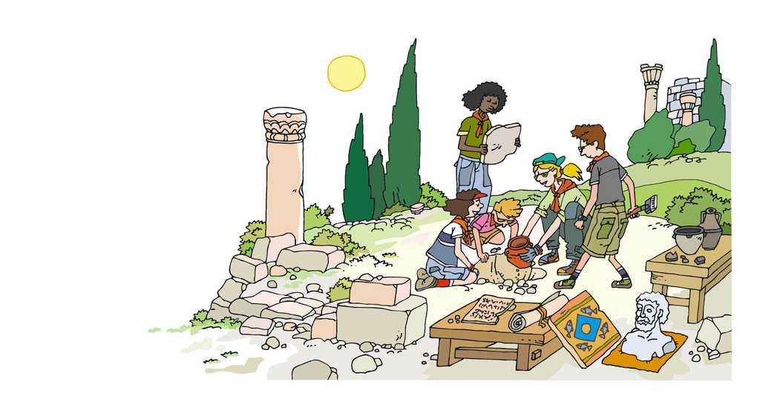
sources
sources

sources

10. Read the sentences about human evolution. Write True (T) or False (F).
● Hominids, the first human ancestors, evolved before the dinosaurs became extinct.

● Humans and chimpanzees have a common ancestor.

● Thousands of years ago, the brains of some hominids became bigger.

11. Look at the picture, identify the historical period and describe it.
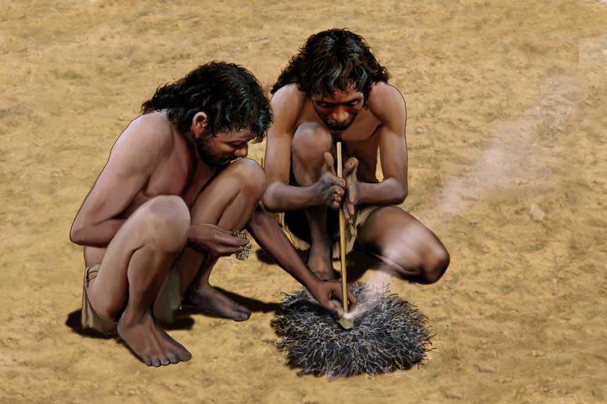

12. Read the sentences about the Palaeolithic period. Then, write True (T) or False (F).
● It is the end of Prehistory.

● Humans made cave paintings.

● Humans invented the loom to weave wool.
13. Match the words with the pictures.

Palaeolithic ●

Neolithic ●

Metal Age ●

● 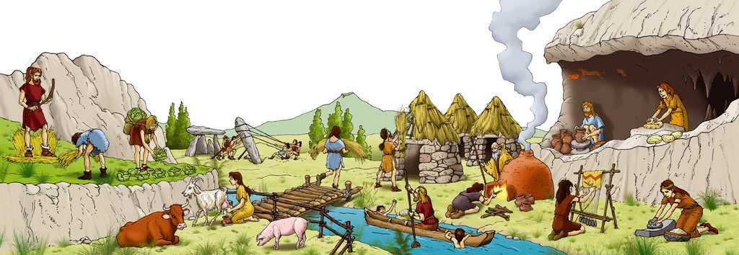

● 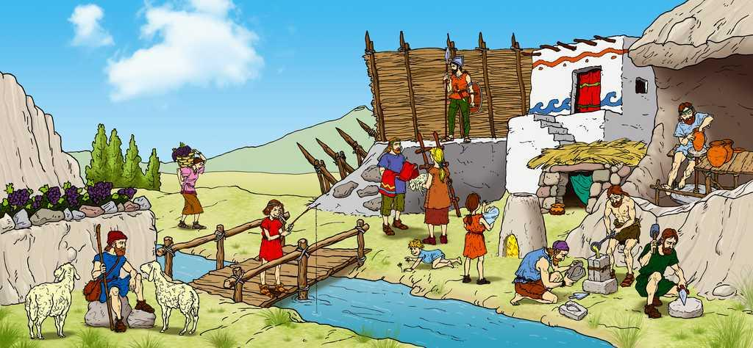

● 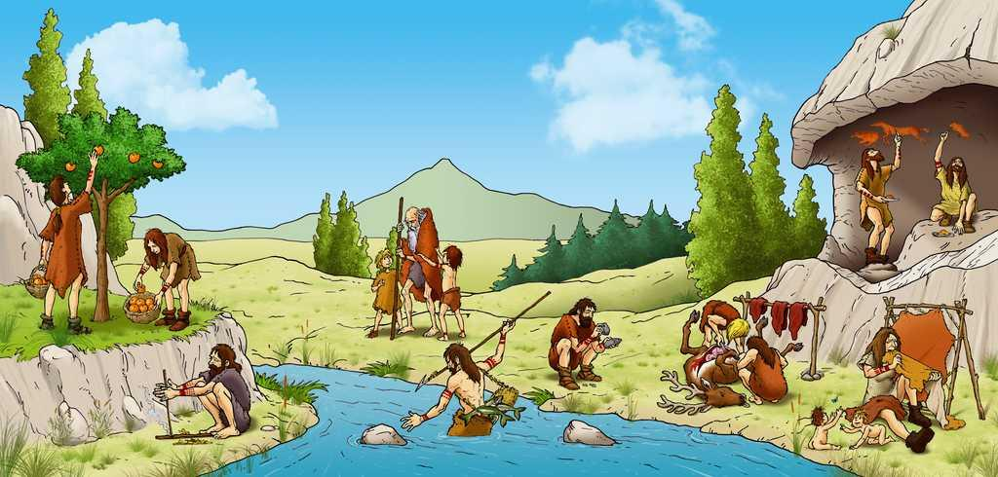

14. Classify when these characteristics first appeared in the chart below.
lived in caves, made fire by hitting stones, developed agriculture and kept livestock, built houses, built walls, developed new forms of transport

Palaeolithic | Neolithic | Metal Age

15. Which sentence describes the Metal Age?
A. Potters began to make clay containers, blacksmiths began to make metal tools, humans began to build walls to protect towns.
B. Humans began to build tombs and to carve stone tools, blacksmiths began to make metal weapons.
C. Humans invented the hand mill to grind cereals, they began to build houses and make metal jewellery.
16. Read and complete the text about the Neolithic period with the words in the box.
megaliths, menhirs, crops, wool, dolmens

The first were cereals. Humans built tombs with large stones called . were standing stones and were made of two or more stones. They obtained meat, milk, skin and from animals.

