1. Write True (T) or False (F).
- The first great civilisations appeared in the river valleys of Asia and Africa.

- Egypt was where people first gathered in large cities, learned to write, made laws and created governments.

- Mesopotamia means land between rivers.

2. Label the picture. Use the words in the box.
market, school, wall, ziggurat, house

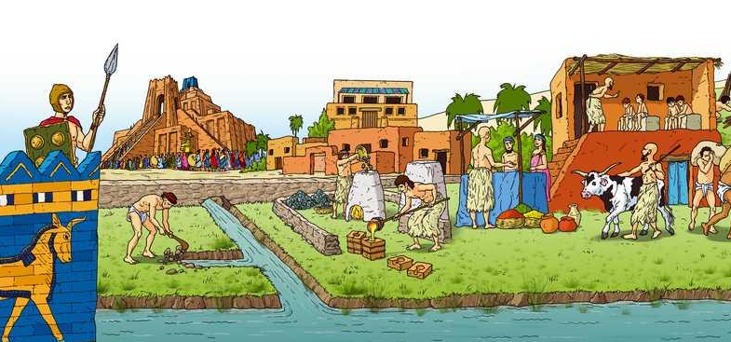

3. Classify these words into the table below.
pyramid, slave, peasant, ziggurat, hieroglyph

Mesopotamia | Egypt

4. Read and complete the text.
The were the kings of Egypt. They were very , and all the land in the country was theirs. The people believed they were . Before they died, they ordered the people to build enormous tombs for them, the
. They were when they died because they believed they would be born into a new . Because of this, the Egyptians buried them with all their belongings and . One of the most famous pharaohs was
.

5. Circle the correct option. The people of Mesopotamia wrote … on clay tablets.
A. hieroglyphs
B. Mesopotamian language
C. pictograms

6. What is a Scribe? What did they do?

7. Label the picture. Use the words in the box.
harbour, wall, agora, theatre, acropolis

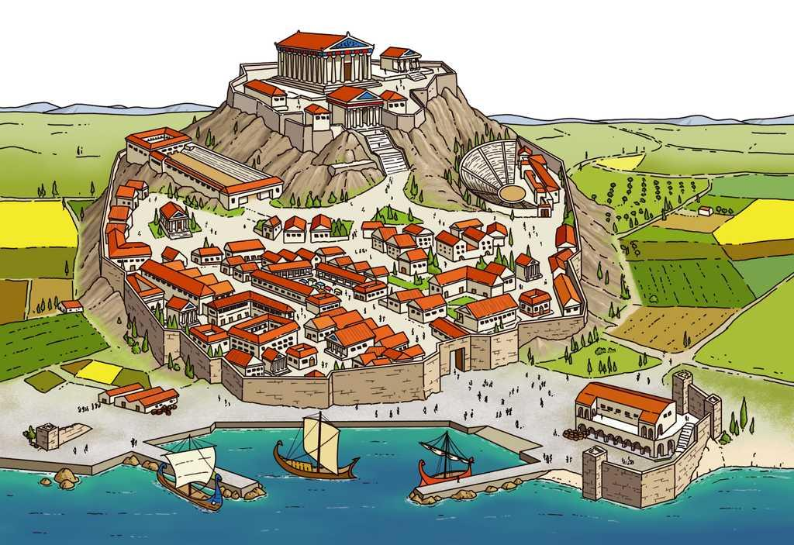
agora

8. Match the words to the examples from Ancient Greece.

Religion ●
Philosophy ●
Poetry and theatre ●
Art ●
● The Iliad and The Odyssey.
● Parthenon temple.
● Polytheistic.
● Plato and Aristotle.

9. Draw some examples of current pictograms.

10. Name one city of each coloniser.
- The Phoenicians:
- The Greeks:

11. Circle the correct sentence about the Romanisation of the peninsula.
A. The population had to obey Roman law.
B. The population spoke latin.
C. They were monotheistic.

12. Write True (T) or False (F).

- The Celtiberians lived in settlements of round houses called castros.

- The Celts lived in fortified settlements.

- The Iberians were great craftsmen.

13. Label the picture. Use the words in the box.
forum, circus, amphitheatre, theatre, triumphal arch, aqueduct

14. Label the pictures. Use the names of the buildings from the previous activity.
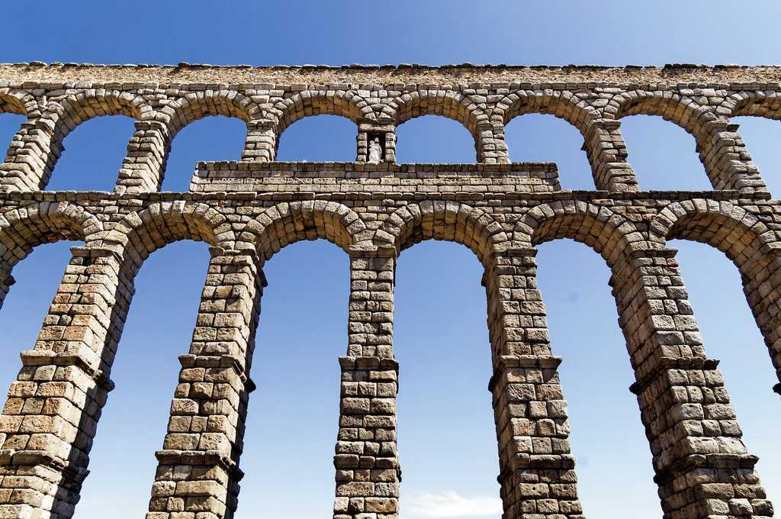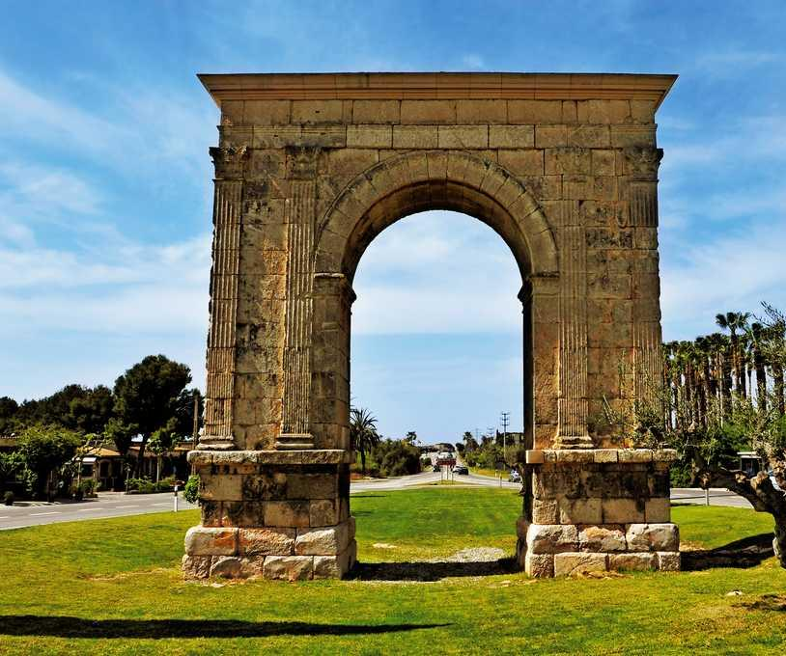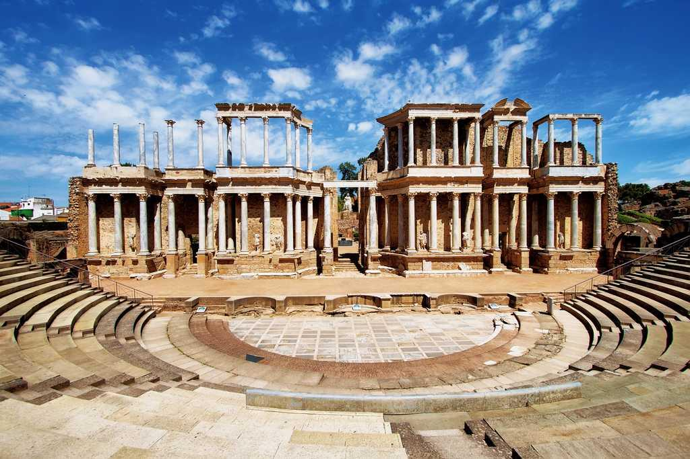

15. Complete the sentences about the Hispania provinces.
- (with its capital Tarraco).
- (with its capital Carthago Nova).
- Baetica (with its capital ).
- Lusitania (with its capital ).
- (with its capital Lucus).

16. Write the modern name of each capital from the previous activity.

