**1. Match the two columns.**

Culture *●*

Society *●*

Politics *●*

Navigation *●*

*●* Monarchs gained more power by expanding their territories.

*●* The invention of the astrolabe, the compass and the portolan charts.

*●* Divided into classes, where the nobility and clergy maintained their privileges.

*●* The invention of the printing press.

**2. Classify the defining characteristics of the three periods of the Modern Age, in the table below.**

authoritarian monarchies, humanism, cultural importance, great advances in science and education, some modernising reforms, new tendencies in art, architecture and literature, political and economic crisis, European monarchies had absolute power, new interest in ancient Greek and Roman culture

|  |  |  |
| --- | --- | --- |
| **Renaissance (16th century)** | **Baroque (17th century)** | **The Age of Enlightenment (18th century)** |
|  |  |  |

**3. Which sentence does not describe the reign of the Catholic Monarchs?**

A. They completed the *Reconquista* in 1492.

B. They were defenders of Islam.

C. They formed a powerful authoritarian monarchy.

D. They formed an efficient government.

**4. Read and complete the text with the words in the box.**

Castilla, *Reconquista*, Africa, European, Canary, Mediterranean

*●* Castilla completed the by taking control of Granada.

*●* The Kingdom of Navarra became part of the Crown of .

*●* Castilla conquered territories in the North of , such as Melilla, Oran and Algiers.

*●* Isabel and Fernando married their children into other monarchies.

*●* Castilla conquered the Islands and reached America.

*●* Aragón expanded along the .

**5. Label the pictures with the words in the box.**

Conquistador, Pre-Columbian, Columbus

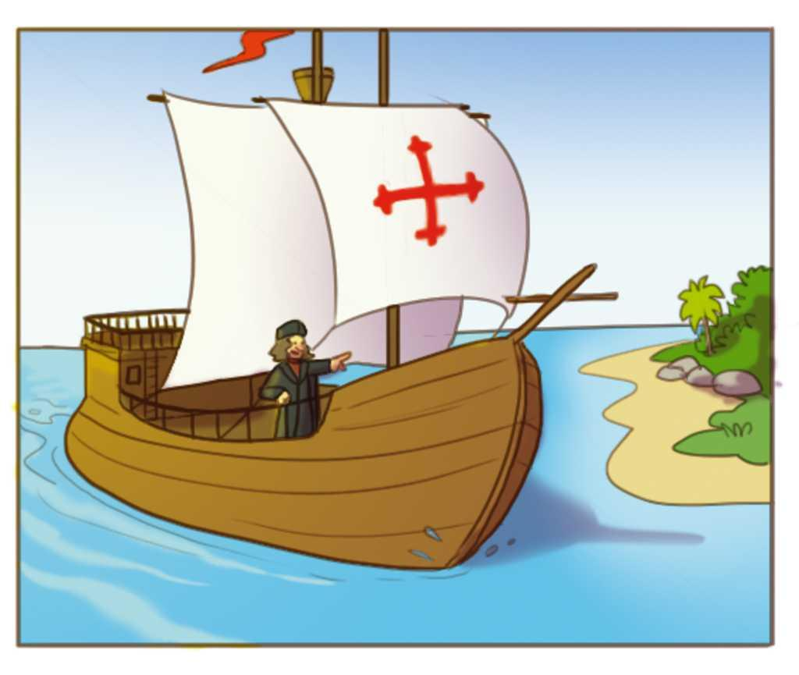 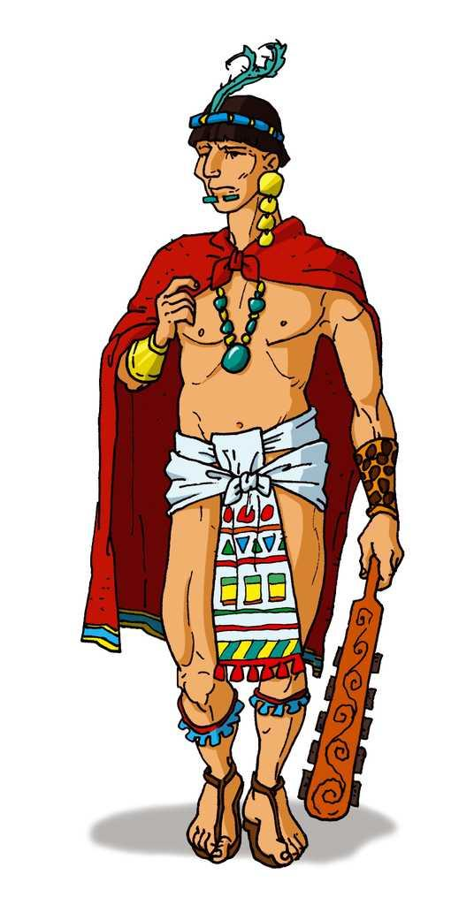 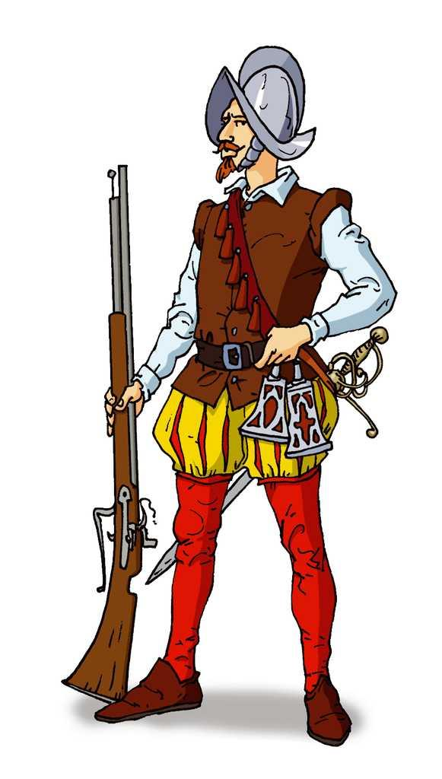

culture

’s ship

**6. Write True (T) or False (F).**

*●* Christopher Columbus knew the Earth was flat.

*●* On the 12th September 1592 Columbus reached dry land.

*●* He thought he was in Asia.

*●* In America there were three great civilisations: Mayans, Aztecs and Incas.

*●* Hernan Cortés and Francisco de Pizarro are best remembered as the leaders of pre-Columbian cultures.

**7. Classify the defining characteristics of the reigns of Carlos I and Felipe II in the table below.**

made Madrid the capital of the Empire, internal rebellion, ruled Portugal

|  |  |
| --- | --- |
| **Carlos I** | **Felipe II** |
|  |  |

**8. Which two sentences below describe the main causes of the crisis in the 17th century?**

A. Bad crops, plagues and emigration to America.

B. Loss of European territories such as Portugal.

C. The strength of the Monarchy in this period.

D. The riches gained in America.

**9. What happened when Carlos II died?**

**10. Write True (T) or False (F).**

*●* 18th century monarchs exercised absolute power.

*●* Two dynasties claimed the Spanish Throne: the French Bourbons and the English Habsburgs.

*●* The Spanish War of Succession started in 1710.

*●* After 12 years of war, the Duke of Anjou became the new King of Spain.

*●* Rousseau wanted to end the inequality between the privileged and non-privileged classes.

*●* Felipe IV’s heirs opened academies, museums, gardens and schools.

**11. Look at the pictures and describe the differences between these two types of theatre and who went to them.**

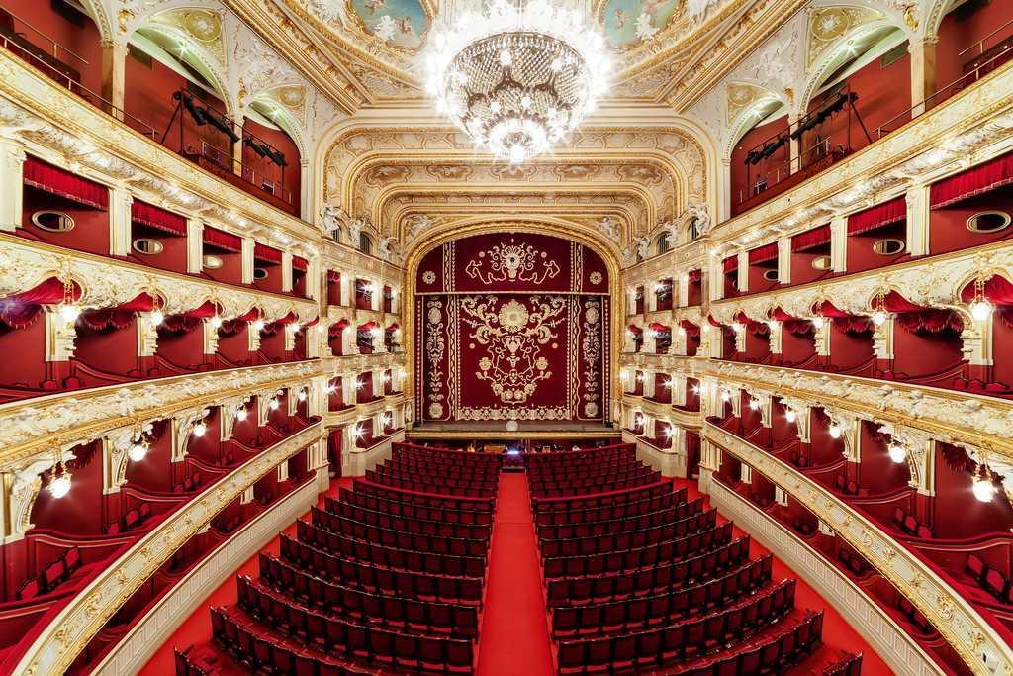 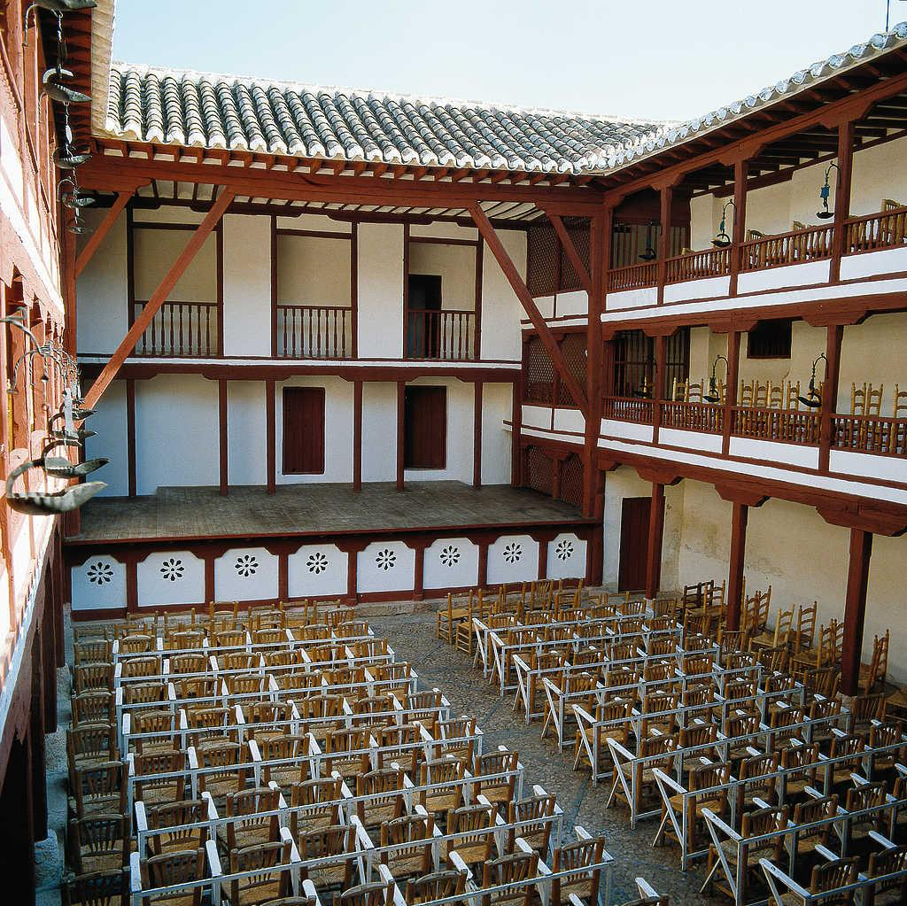

**12. Which person is not a writer from the Golden Age? Circle.**

A. Miguel de Cervantes.

B. Calderón de la Barca.

C. Antonio Machado.

D. Lope de Vega.

**13. Complete the text about the differences between the lives of a noblewoman and a peasant woman in the Modern Age.**

A spent her time studying music, reading poetry and languages. She didn’t work the land, but she took care of the and her children.

A worked from sunrise to . She didn’t have the right to own . She had a lot of children to take care of.

**14. Complete the table about art in the Modern Age.**

|  |  |  |  |  |
| --- | --- | --- | --- | --- |
| **Period** | **Place** | **Topic** | **Style** | **Characteristics** |
|  |  | Classical mythology |  |  |
|  | Italy and Spain |  | Realistic style | Movements and expression |

**15. Look at the paintings. Label them with the name of the period they come from.**

